Maths Term 2 Stage 2- Year 4 - 2020
Duration: 10 weeks – 5x 1hr lessons per week |  | Prior Knowledge: Insert expected prior knowledge here
Unit Description and Organisation  During each unit, students will explore skills for working mathematically as they engage in content. Students are taught specific skills and strategies for each content area. Students will be provided with opportunities to manipulate concrete materials as they develop mathematical knowledge. |  | Links to other KLAs  - English – language  - Science - 3D space – things that move  - Creative Arts – Patterns with sounds |  |  | Each unit of work will incorporate formative and summative assessment:  Formative assessment:  - Observation notes/anecdotal records as lesson annotations. This may also include formative assessments as lesson sequence (as indicated)  Summative assessment:  - Grade assessment to be completed at the end of each unit- this will be included in the lesson program and may be completed during rotations or as whole class.
Quality Teaching Framework | Intellectual Quality  Deep knowledge - Deep understanding - Problematic knowledge - Higher-order thinking – Metalanguage - Substantive communication |  | Quality Leaning Environment  Explicit quality criteria – Engagement - High expectations - Social support - Students’ self-regulation - Student direction |  |  | Significance  Background knowledge - Cultural knowledge - Knowledge integration – Inclusivity – Connectedness - Narrative
Learning Across the Curriculum | Literacy – Numeracy – Critical & creative thinking – Ethical understanding – Personal and social capabilities – Intercultural understanding – ICT – Sustainability – Aboriginal/Torres Strait Islanders histories and culture – Australia’s engagement with Asia – Difference & diversity – Civics & citizenship – Work & enterprise
Learning Progressions | Speaking & Listening  Listening – Interacting - Speaking |  |  | Reading & Viewing  Phonological awareness – Phonic knowledge and word recognition – Fluency – Understanding Texts - |  |  | Writing  Creating texts (informative/persuasive/imaginative) – Grammar – Punctuation – Spelling – Handwriting & keyboarding
 | Number Sense & Algebra  Quantifying numbers – Additive strategies – Multiplicative strategies – Operating with decimals – Operating with percentages – understanding money – Number patterns and algebraic thinking – Comparing units (ratios/rates/proportion) – Interpreting fractions |  |  | Measurement & Geometry  Understanding units of measurement – Understanding geometric properties – Positioning & locating – Measuring time |  |  | Statistics & Probability  Understanding chance – Interpreting & representing data
.
Term 2 Scope & Sequence (Year 4)
Multiplication and Division 2a | Area 2a | 2D Space 2a | Fractions and Decimals 2a | Volume and Capacity 2a | Position 2a | Data 2a | Angles 2a | Revision
5 lessons and assessment | 3-4 lessons and assessment | 3 lessons and assessment | 3-4 lessons and assessment | 3 lessons and assessment | 4 lessons and assessment | 2-3 lessons and assessment | 2-3 lessons and assessment
MA2-1WM, MA2-2WM, MA2-3WM, MA2-6NA | MA2-1WM, MA2-2WM, MA2-10MG | MA2-1WM, MA2-2WM, MA2-3WM, MA2-15MG | MA2-1WM, MA2-3WM, MA2-7NA | MA2-1WM, MA2-11MG | MA2-1WM, MA2-17MG | MA2-1WM, MA2-2WM, MA2-3WM, MA2-18SP | MA2-1WM, MA2-3WM, MA2-16MG
Skip counting and finding multiples  Using mental strategies to build multiplication facts  Recalling multiplication facts and relating to inverse operations  Determining factors  Recording equivalent number relationships | Measuring areas of common 2D shapes  Measuring area of irregular shapes using informal means  Comparing areas of regular and irregular shapes using informal means | Combining 2D shapes to make new shapes  Splitting 2D shapes into new shapes  Recording arrangements of shapes that make other shapes | Modelling, comparing and representing fractions  Recognising and applying decimal notation  Stating place value of digits in decimals up to 2 decimal places  Using place value to partition decimals | Recognising need for smaller unit than the litre  Understanding conversions of measurement of volume and capacity  Making calibrated measuring devices  Recording measurements for volumes and capacities using 'mm' | Using legends or keys to locate objects on a map  Using a compass to find direction points  Determing directions N S E W NE NW SE SW  Using compass directions to describe the location of an object on a map | Creating a survey and collecting data (refining survey questions as needed)  Conducting survey and comparing effectiveness of collecting and recording data | Comparing angles using informal means  Describing angles using simple terminology  Classifying angles

Teaching and Learning Program: Multiplication and Division 2a
Outcomes  - MA2-1WM uses appropriate terminology to describe, and symbols to represent, mathematical ideas  - MA2-2WM selects and uses appropriate mental or written strategies, or technology, to solve problems  - MA2-3WM checks the accuracy of a statement and explains the reasoning used  - MA2-6NA uses mental and informal written strategies for multiplication and division | Summary and assessment overview  Skip counting and finding multiples  Using mental strategies to build multiplication facts  Recalling multiplication facts and relating to inverse operations  Determining factors  Recording equivalent number relationships
Mathematical Language Students should be able to communicate using the following language: group, row, column, horizontal, vertical, array, multiply, multiplied by, multiplication, multiplication facts, double, shared between, divide, divided by, division, equals, strategy, digit, number chart.

 | Content | Lessons (embed resources) | Differentiation | Annotations/ Evidence of Learning | Reg
1 | Recall multiplication facts up to 10 × 10 and related division facts (ACMNA075)  - count by fours, sixes, sevens, eights and nines using skip counting  - use the term 'product' to describe the result of multiplying two or more numbers, e.g. 'The product of 5 and 6 is 30'   - use mental strategies to build multiplication facts to at least 10 × 10, including:   - using the commutative property of multiplication, e.g. 7 × 9 = 9 × 7  - using known facts to work out unknown facts, e.g. 5 × 7 is 35, so 6 × 7 is 7 more, which is 42  - using doubling and repeated doubling as a strategy to multiply by 2, 4 and 8, e.g. 7 × 8 is double 7, double again and then double again  - using the relationship between multiplication facts, e.g. the multiplication facts for 6 are double the multiplication facts for 3  - factorising one number, eg 5 × 8 is the same as 5 × 2 × 4, which becomes 10 × 4 | Learning Intention:  Success Criteria:  Tasks:
2 | Recall multiplication facts up to 10 × 10 and related division facts (ACMNA075)  - recall multiplication facts up to 10 × 10, including zero facts, with automaticity  - find 'multiples' for a given whole number, e.g. the multiples of 4 are 4, 8, 12, 16, … | Learning Intention:  Success Criteria:  Tasks:
3 | Recall multiplication facts up to 10 × 10 and related division facts (ACMNA075)  - relate multiplication facts to their inverse division facts, e.g. 6 × 4 = 24, so 24 ÷ 6 = 4 and 24 ÷ 4 = 6 | Learning Intention:  Success Criteria:  Tasks:
4 | Recall multiplication facts up to 10 × 10 and related division facts (ACMNA075)  - determine 'factors' for a given whole number, e.g. the factors of 12 are 1, 2, 3, 4, 6, 12  - use the equals sign to record equivalent number relationships involving multiplication, and to mean 'is the same as', rather than to mean to perform an operation, e.g. 4 × 3 = 6 × 2  - connect number relationships involving multiplication to factors of a number, e.g. 'Since 4 × 3 = 6 × 2, then 4, 3, 2 and 6 are factors of 12' (Communicating, Reasoning)  - check number sentences to determine if they are true or false and explain why, e.g. 'Is 7 × 5 = 8 × 4 true? Why or why not?' (Communicating, Reasoning) | Learning Intention:  Success Criteria:  Tasks:
Summative Evaluation
- Were the program outcomes achieved?
- Were the activities relevant and appropriate to the needs of the students?
- What teaching strategy was most effective?
- Did students enjoy the program?
- Were there sufficient challenging opportunities for extension?
- What would I change next time?
Teaching and Learning Program: Area 2a
Outcomes  - MA2-1WM uses appropriate terminology to describe, and symbols to represent, mathematical ideas  - MA2-2WM selects and uses appropriate mental or written strategies, or technology, to solve problems  - MA2-10MG measures, records, compares and estimates areas using square centimetres and square metres | Summary and assessment overview  Measuring areas of common 2D shapes  Measuring area of irregular shapes using informal means  Comparing areas of regular and irregular shapes using informal means
Mathematical Language Students should be able to communicate using the following language: area, surface, measure, grid, row, column, square centimetre, square metre, and estimate.

 | Content | Lessons (embed resources) | Differentiation | Annotations/ Evidence of Learning | Reg
1 | Compare the areas of regular and irregular shapes by informal means (ACMMG087)  - measure the areas of common two-dimensional shapes using a square-centimetre grid overlay, e.g. measure the area of a regular hexagon  - compare how different placements of a grid overlay make measuring area easier or harder, e.g. 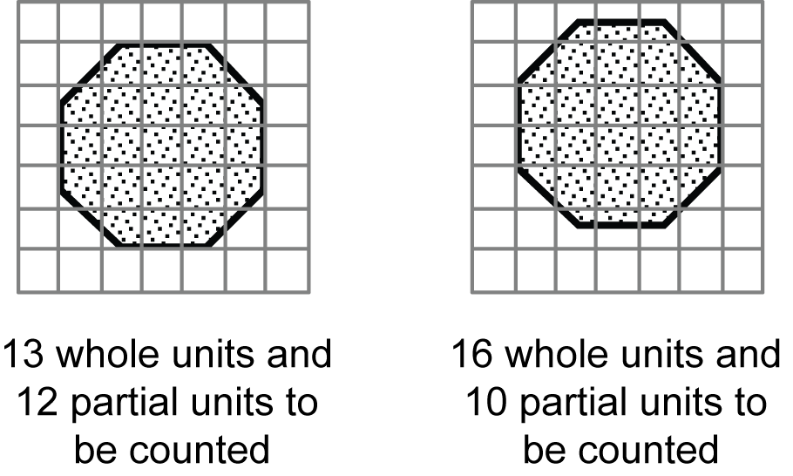(Problem Solving)  - develop strategies for counting partial units in the total area of the shape, e.g. determine two or more partial units that combine to form one whole unit (Communicating, Problem Solving) | Learning Intention:  Success Criteria:  Tasks:
2 | Compare the areas of regular and irregular shapes by informal means (ACMMG087)  - measure the areas of irregular shapes using a square-centimetre grid overlay, e.g.  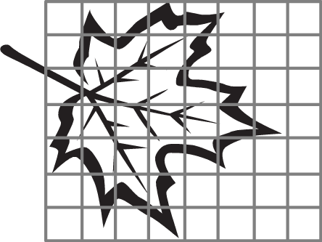 | Learning Intention:  Success Criteria:  Tasks:
Summative Evaluation
- Were the program outcomes achieved?
- Were the activities relevant and appropriate to the needs of the students?
- What teaching strategy was most effective?
- Did students enjoy the program?
- Were there sufficient challenging opportunities for extension?
- What would I change next time?

Teaching and Learning Program: 2D Space 2a
Outcomes  - MA2-1WM uses appropriate terminology to describe, and symbols to represent, mathematical ideas  - MA2-2WM selects and uses appropriate mental or written strategies, or technology, to solve problems  - MA2-3WM checks the accuracy of a statement and explains the reasoning used  - MA2-15MG manipulates, identifies and sketches two-dimensional shapes, including special quadrilaterals, and describes their features | Summary and assessment overview  Combining 2D shapes to make new shapes  Splitting 2D shapes into new shapes  Recording arrangements of shapes that make other shapes
Mathematical Language Students should be able to communicate using the following language: shape, two-dimensional shape (2D shape), circle, triangle, quadrilateral, parallelogram, rectangle, rhombus, square, trapezium, kite, pentagon, hexagon, octagon, regular shape, irregular shape, orientation, features, properties, side, parallel, pair of parallel sides, opposite, length, vertex (vertices), angle, right angle, symmetry, line (axis) of symmetry, rigid.

 | Content | Lessons (embed resources) | Differentiation | Annotations/ Evidence of Learning | Reg
1 | Compare and describe two-dimensional shapes that result from combining and splitting common shapes, with and without the use of digital technologies (ACMMG088)  - combine common two-dimensional shapes, including special quadrilaterals, to form other common shapes or designs, e.g. combine a rhombus and a triangle to form a trapezium  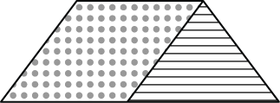  - describe and/or name the shape formed from a combination of common shapes (Communicating)  - follow written or verbal instructions to create a common shape using a specified set of two or more common shapes, e.g. create an octagon from five squares and four triangles (Communicating, Problem Solving)  - use digital technologies to construct a design or logo by combining common shapes (Communicating)  | Learning Intention:  Success Criteria:  Tasks:
2 | Compare and describe two-dimensional shapes that result from combining and splitting common shapes, with and without the use of digital technologies (ACMMG088)  - split a given shape into two or more common shapes and describe the result, e.g. 'I split the parallelogram into a rectangle and two equal-sized triangles'  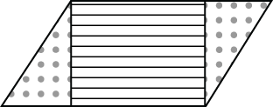  - compare the area of the given shape with the area of each of the shapes it is split into, e.g. if a pentagon is split into five equal triangles, describe the area of the pentagon as five times the area of one triangle, or the area of one triangle as of the area of the pentagon (Communicating, Reasoning) | Learning Intention:  Success Criteria:  Tasks:
3 | Compare and describe two-dimensional shapes that result from combining and splitting common shapes, with and without the use of digital technologies (ACMMG088)  - record the arrangements of common shapes used to create other shapes, and the arrangement of shapes formed after splitting a shape, in diagrammatic form, with and without the use of digital technologies  - record different combinations of common shapes that can be used to form a particular regular polygon, e.g. a hexagon can be created from, or split into, many different arrangements, such as  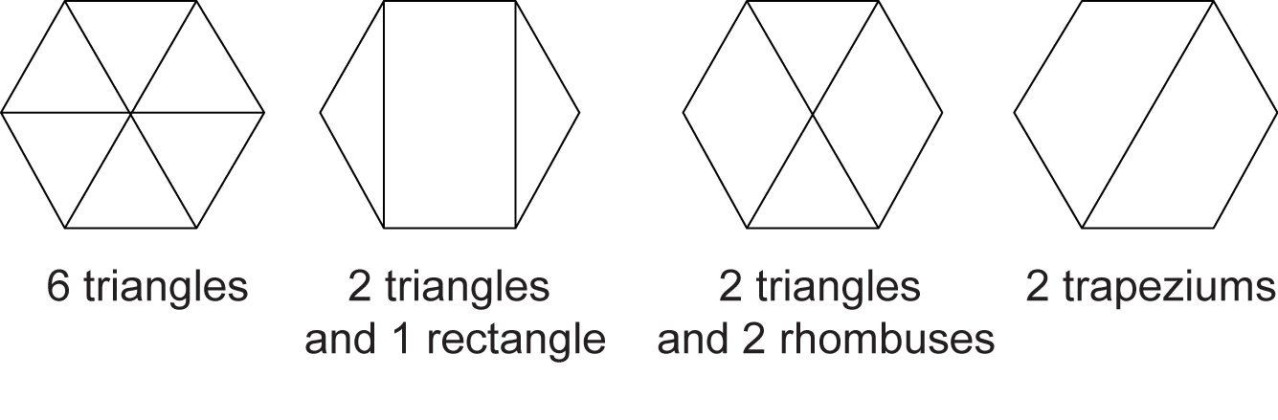  (Communicating, Problem Solving) | Learning Intention:  Success Criteria:  Tasks:
Summative Evaluation
- Were the program outcomes achieved?
- Were the activities relevant and appropriate to the needs of the students?
- What teaching strategy was most effective?
- Did students enjoy the program?
- Were there sufficient challenging opportunities for extension?
- What would I change next time?
Teaching and Learning Program: Fractions and Decimals 2a
Outcome  - MA2-1WM uses appropriate terminology to describe, and symbols to represent, mathematical ideas  - MA2-3WM checks the accuracy of a statement and explains the reasoning used  - MA2-7NA represents, models and compares commonly used fractions and decimals | Summary and assessment overview  Modelling, comparing and representing fractions  Recognising and applying decimal notation  Stating place value of digits in decimals up to 2 decimal places  Using place value to partition decimals
Mathematical Language Students should be able to communicate using the following language: whole, part, equal parts, half, quarter, eighth, third, fifth, one-third, one-fifth, fraction, denominator, numerator, mixed numeral, whole number, fractional part, number line.

 | Content | Lessons (embed resources) | Differentiation | Annotations/ Evidence of Learning | Reg
1 | Investigate equivalent fractions used in contexts (ACMNA077)  - model, compare and represent fractions with denominators of 2, 4 and 8; 3 and 6; and 5, 10 and 100  - model, compare and represent the equivalence of fractions with related denominators by redividing the whole, using concrete materials, diagrams and number lines, eg  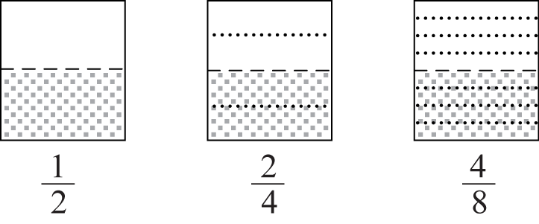  - record equivalent fractions using diagrams and numerals, eg 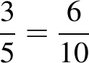 | Learning Intention:  Success Criteria:  Tasks:
2 | Recognise that the place value system can be extended to tenths and hundredths, and make connections between fractions and decimal notation (ACMNA079)  - recognise and apply decimal notation to express whole numbers, tenths and hundredths as decimals, e.g. 0.1 is the same as 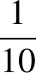  - investigate equivalences using various methods, e.g. use a number line or a calculator to show that is the same as 0.5 and 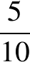 (Communicating, Reasoning)  - identify and interpret the everyday use of fractions and decimals, such as those in advertisements (Communicating, Problem Solving)  - state the place value of digits in decimal numbers of up to two decimal places | Learning Intention:  Success Criteria:  Tasks:
3 | Recognise that the place value system can be extended to tenths and hundredths, and make connections between fractions and decimal notation (ACMNA079)  - use place value to partition decimals of up to two decimal places, e.g. 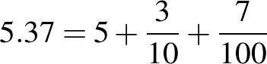  - partition decimals of up to two decimal places in non-standard forms, e.g. 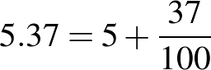  - apply knowledge of hundredths to represent amounts of money in decimal form, e.g. five dollars and 35 cents is 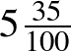, which is the same as $5.35 (Communicating) | Learning Intention:  Success Criteria:  Tasks:
Summative Evaluation
- Were the program outcomes achieved?
- Were the activities relevant and appropriate to the needs of the students?
- What teaching strategy was most effective?
- Did students enjoy the program?
- Were there sufficient challenging opportunities for extension?
- What would I change next time?

Teaching and Learning Program: Volume and Capacity 2a
Outcomes  - MA2-1WM uses appropriate terminology to describe, and symbols to represent, mathematical ideas  - MA2-11MG measures, records, compares and estimates volumes and capacities using litres, millilitres and cubic centimetres | Summary and assessment overview  Recognising need for smaller unit than the litre  Understanding conversions of measurement of volume and capacity  Making calibrated measuring devices  Recording measurements for volumes and capacities using 'mm'
Mathematical Language Students should be able to communicate using the following language: capacity, container, litre, volume, layers, cubic centimetre, measure, and estimate.

 | Content | Lessons (embed resources) | Differentiation | Annotations/ Evidence of Learning | Reg
1 | Use scaled instruments to measure and compare capacities (ACMMG084)  - recognise the need for a formal unit smaller than the litre to measure volume and capacity  - recognise that there are 1000 millilitres in one litre, i.e. 1000 millilitres = 1 litre  - relate the millilitre to familiar everyday containers and familiar informal units, e.g. 250 mL fruit juice containers, 1 teaspoon is approximately 5 mL (Reasoning) | Learning Intention:  Success Criteria:  Tasks:
2 | Use scaled instruments to measure and compare capacities (ACMMG084)  - make a measuring device calibrated in multiples of 100 mL to measure volume and capacity to the nearest 100 mL  - use the millilitre as a unit to measure volume and capacity, using a device calibrated in millilitres, e.g. place a measuring cylinder under a dripping tap to measure the volume of water lost over a particular period of time  - record volumes and capacities using the abbreviation for millilitres (mL) | Learning Intention:  Success Criteria:  Tasks:
Summative Evaluation
- Were the program outcomes achieved?
- Were the activities relevant and appropriate to the needs of the students?
- What teaching strategy was most effective?
- Did students enjoy the program?
- Were there sufficient challenging opportunities for extension?
- What would I change next time?
Teaching and Learning Program: Position 2a
Outcomes  - MA2-1WM uses appropriate terminology to describe, and symbols to represent, mathematical ideas  - MA2-17MG uses simple maps and grids to represent position and follow routes, including using compass directions | Summary and assessment overview  Using legends or keys to locate objects on a map  Using a compass to find direction points  Determining directions N S E W NE NW SE SW  Using compass directions to describe the location of an object on a map
Mathematical Language Students should be able to communicate using the following language: position, location, map, plan, path, route, grid, grid reference, aerial view, directions.

 | Content | Lessons (embed resources) | Differentiation | Annotations/ Evidence of Learning | Reg
1 | Use simple scales, legends and directions to interpret information contained in basic maps (ACMMG090)  - use a legend (or key) to locate specific objects on a map | Learning Intention:  Success Criteria:  Tasks:
2 | Use simple scales, legends and directions to interpret information contained in basic maps (ACMMG090)  - use a compass to find north and then east, south and west  - use N, E, S and W to indicate north, east, south and west, respectively, on a compass rose  - use an arrow to represent north on a map  - determine the directions north, east, south and west when given one of the directions  - use NE, SE, SW and NW to indicate north-east, south-east, south-west and north-west, respectively, on a compass rose, e.g.  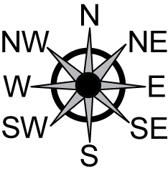 | Learning Intention:  Success Criteria:  Tasks:
3 | Use simple scales, legends and directions to interpret information contained in basic maps (ACMMG090)  - use north, east, south and west to describe the location of a particular object in relation to another object on a simple map, given an arrow that represents north, e.g. 'The treasure is east of the cave'  - determine the directions NE, SE, SW and NW when given one of the directions  - use north-east, south-east, south-west and north-west to describe the location of an object on simple maps, given a compass rose, e.g. 'The tree is south-west of the sign' | Learning Intention:  Success Criteria:  Tasks:
Summative Evaluation
- Were the program outcomes achieved?
- Were the activities relevant and appropriate to the needs of the students?
- What teaching strategy was most effective?
- Did students enjoy the program?
- Were there sufficient challenging opportunities for extension?
- What would I change next time?

Teaching and Learning Program: Data 2a
Outcomes  - MA2-1WM uses appropriate terminology to describe, and symbols to represent, mathematical ideas  - MA2-2WM selects and uses appropriate mental or written strategies, or technology, to solve problems  - MA2-3WM checks the accuracy of a statement and explains the reasoning used  - MA2-18SP selects appropriate methods to collect data, and constructs, compares, interprets and evaluates data displays, including tables, picture graphs and column graphs | Summary and assessment overview  Creating a survey and collecting data (refining survey questions as needed)  Conducting survey and comparing effectiveness of collecting and recording data
Mathematical Language Students should be able to communicate using the following language: information, data, collect, category, display, symbol, list, table, column graph, picture graph, vertical columns, horizontal bars, equal spacing, title, key, vertical axis, horizontal axis, axes, spreadsheet.

 | Content | Lessons (embed resources) | Differentiation | Annotations/ Evidence of Learning | Reg
1 | Select and trial methods for data collection, including survey questions and recording sheets (ACMSP095)  - create a survey and related recording sheet, considering the appropriate organisation of categories for data collection  - choose effective ways to collect and record data for an investigation, e.g. creating a survey with a scale of 1 to 5 to indicate preferences (1 = don't like, 2 = like a little, 3 = don't know, 4 = like, 5 = like a lot) (Communicating, Problem Solving)  - refine survey questions as necessary after a small trial  - discuss and decide the most suitable question to investigate a particular matter of interest, e.g. by narrowing the focus of a question from 'What is the most popular playground game?' to 'What is the most popular playground game among Year 3 students at our school?' (Communicating, Reasoning) | Learning Intention:  Success Criteria:  Tasks:
2 | Select and trial methods for data collection, including survey questions and recording sheets (ACMSP095)  - conduct a survey to collect categorical data  - after conducting a survey, discuss and determine possible improvements to the questions or recording sheet (Communicating, Reasoning)  - compare the effectiveness of different methods of collecting and recording data, e.g. creating categories of playground games and using tally marks, compared to asking open-ended questions such as 'What playground game do you like to play?'  - discuss the advantages and/or disadvantages of open-ended questions in a survey, compared to questions with predetermined categories (Communicating, Reasoning) | Learning Intention:  Success Criteria:  Tasks:
Summative Evaluation
- Were the program outcomes achieved?
- Were the activities relevant and appropriate to the needs of the students?
- What teaching strategy was most effective?
- Did students enjoy the program?
- Were there sufficient challenging opportunities for extension?
- What would I change next time?

Teaching and Learning Program: Angles 2a
Outcomes  - MA2-1WM uses appropriate terminology to describe, and symbols to represent, mathematical ideas  - MA2-3WM checks the accuracy of a statement and explains the reasoning used  - MA2-16MG identifies, describes, compares and classifies angles | Summary and assessment overview  Comparing angles using informal means  Describing angles using simple terminology  Classifying angles
Mathematical Language Students should be able to communicate using the following language: information, data, collect, category, display, symbol, list, table, column graph, picture graph, vertical columns, horizontal bars, equal spacing, title, key, vertical axis, horizontal axis, axes, spreadsheet.

 | Content | Lessons (embed resources) | Differentiation | Annotations/ Evidence of Learning | Reg
1 | Compare angles and classify them as equal to, greater than or less than a right angle (ACMMG089)  - compare angles using informal means, such as by using an 'angle tester'  - recognise and describe angles as 'less than', 'equal to', 'about the same as' or 'greater than' a right angle | Learning Intention:  Success Criteria:  Tasks:
2 | Compare angles and classify them as equal to, greater than or less than a right angle (ACMMG089)  - classify angles as acute, right, obtuse, straight, reflex or a revolution  - describe the size of different types of angles in relation to a right angle, e.g. acute angles are less than a right angle (Communicating)  - relate the turn of the hour hand on a clock through a right angle or straight angle to the number of hours elapsed, e.g. a turn through a right angle represents the passing of three hours (Reasoning) | Learning Intention:  Success Criteria:  Tasks:  - step
Summative Evaluation
- Were the program outcomes achieved?
- Were the activities relevant and appropriate to the needs of the students?
- What teaching strategy was most effective?
- Did students enjoy the program?
- Were there sufficient challenging opportunities for extension?
- What would I change next time?

Teaching and Learning Program: Revision
Outcomes | Summary and assessment overview
Mathematical Language Students should | Summary and assessment overview

 | Content | Lessons (embed resources) | Differentiation | Annotations/ Evidence of Learning | Reg
1 |  | Learning Intention:  Success Criteria:  Tasks:
2 |  | Learning Intention:  Success Criteria:  Tasks:
3 |  | Learning Intention:  Success Criteria:  Tasks:
4 |  | Learning Intention:  Success Criteria:  Tasks:
5 |  | Learning Intention:  Success Criteria:  Tasks:
Summative Evaluation
- Were the program outcomes achieved?
- Were the activities relevant and appropriate to the needs of the students?
- What teaching strategy was most effective?
- Did students enjoy the program?
- Were there sufficient challenging opportunities for extension?
- What would I change next time?

