Maths Term 2 Stage 3- Year 6 - 2020
Duration: 10 weeks – 5x 1hr lessons per week |  | Prior Knowledge: Insert expected prior knowledge here
Unit Description and Organisation  During each unit, students will explore skills for working mathematically as they engage in content. Students are taught specific skills and strategies for each content area. Students will be provided with opportunities to manipulate concrete materials as they develop mathematical knowledge. |  | Links to other KLAs  - English – language  - Science - 3D space – things that move  - Creative Arts – Patterns with sounds |  |  | Each unit of work will incorporate formative and summative assessment:  Formative assessment:  - Observation notes/anecdotal records as lesson annotations. This may also include formative assessments as lesson sequence (as indicated)  Summative assessment:  - Grade assessment to be completed at the end of each unit- this will be included in the lesson program and may be completed during rotations or as whole class.
Quality Teaching Framework | Intellectual Quality  Deep knowledge - Deep understanding - Problematic knowledge - Higher-order thinking – Metalanguage - Substantive communication |  | Quality Leaning Environment  Explicit quality criteria – Engagement - High expectations - Social support - Students’ self-regulation - Student direction |  |  | Significance  Background knowledge - Cultural knowledge - Knowledge integration – Inclusivity – Connectedness - Narrative
Learning Across the Curriculum | Literacy – Numeracy – Critical & creative thinking – Ethical understanding – Personal and social capabilities – Intercultural understanding – ICT – Sustainability – Aboriginal/Torres Strait Islanders histories and culture – Australia’s engagement with Asia – Difference & diversity – Civics & citizenship – Work & enterprise
Learning Progressions | Speaking & Listening  Listening – Interacting - Speaking |  |  | Reading & Viewing  Phonological awareness – Phonic knowledge and word recognition – Fluency – Understanding Texts - |  |  | Writing  Creating texts (informative/persuasive/imaginative) – Grammar – Punctuation – Spelling – Handwriting & keyboarding
 | Number Sense & Algebra  Quantifying numbers – Additive strategies – Multiplicative strategies – Operating with decimals – Operating with percentages – understanding money – Number patterns and algebraic thinking – Comparing units (ratios/rates/proportion) – Interpreting fractions |  |  | Measurement & Geometry  Understanding units of measurement – Understanding geometric properties – Positioning & locating – Measuring time |  |  | Statistics & Probability  Understanding chance – Interpreting & representing data

Term 2 Scope and Sequence (Year 6)
Multiplication and Division 2a | Area 2a | 2D Space 2a | Fractions and Decimals 2a | Volume and Capacity 2a | Position 1a | Data 2a | Angles 2a | Revision
6 lessons and assessment | 3-4 lessons and assessment | 3 lessons and assessment | 6 lessons and assessment | 3-4 lessons and assessment | 2 to 3 lessons and assessment | 3 lessons and assessment | 4 to 5 lessons and assessment
MA3-1WM, MA3-2WM, MA3-3WM, MA3-6NA | MA3-1WM, MA3-2WM, MA3-10MG | MA3-1WM, MA3-2WM, MA3-15MG | MA3-1WM, MA3-2WM, MA3-3WM, MA3-7NA | MA3-1WM, MA3-2WM, MA3-3WM, MA3-11MG | MA3-1WM, MA3-17MG | MA3-1WM, MA3-3WM, MA3-18SP | MA3-1WM, MA3-16MG
Using mental and written strategies to multiply whole numbers up to 4 digit by 1 and 2 digits  Using mental and written strategies to divide whole numbers up to 4 digit by 1 digit (including with remainders)  Multipling and dividing by 10, 100, 1000 and their multiples  Solving word problems of multiplication and division  Solving simple problems involving speed | Investigating area of a triangle  Recording method to find area of triangle  Comparing area of triangle and rectangle  Establishing relationship between base length, perpendicular height and area of triangle | Identifying, determining and drawing the diagonals of 2D shapes  Comparing and describing diagonals of different 2D shapes  Identifying and naming parts of a circle | Modelling, comparing and representing fractions  Comparing and ordering fractions  Generating and recording equivalent fractions  Adding and subtracting fractions | Selecting appropriate units to measure volume and capacity  Converting between cubic centimetres/meters to millilitres/litres  Recognising equivalence between whole number and decimal notation for measurement of capacity  Recording measurements of volume and capacity | Locating position on map using grid reference  Describing location on map using grid reference  Describing routes using landmarks and directions  Describing directions of locations in relation to another | Creating and interpreting data in two way tables  Interpreting side by side graphs for categorical variables  Interpreting and comparing different displays of same data | Identifying and naming angle types  Investigating adjacent angles and angles at a point  Using established dimensions to find size of unknown angles
.

Teaching and Learning Program: Multiplication and Division 2a
Outcomes  - MA3-1WM describes and represents mathematical situations in a variety of ways using mathematical terminology and some conventions  - MA3-2WM selects and applies appropriate problem-solving strategies, including the use of digital technologies, in undertaking investigations  - MA3-3WM gives a valid reason for supporting one possible solution over another  - MA3-6NA selects and applies appropriate strategies for multiplication and division, and applies the order of operations to calculations involving more than one operation | Using mental and written strategies to multiply whole numbers up to 4 digit by 1 and 2 digits  Using mental and written strategies to divide whole numbers up to 4 digit by 1 digit (including with remainders)  Multiplying and dividing by 10, 100, 1000 and their multiples  Solving word problems of multiplication and division  Solving simple problems involving speed
Mathematical Language: Students should be able to communicate using the following language: multiply, multiplied by, product, multiplication, multiplication facts, area, thousands, hundreds, tens, ones, double, multiple, factor, divide, divided by, quotient, division, halve, remainder, fraction, decimal, equals, strategy, digit, estimate, speed, per, operations, order of operations, grouping symbols, brackets, number sentence, is the same as.

 | Content | Lessons (embed resources) | Differentiation | Annotations/ Evidence of Learning | Reg
1 | Select and apply efficient mental and written strategies, and appropriate digital technologies, to solve problems involving multiplication and division with whole numbers (ACMNA123)  - select and use efficient mental and written strategies, and digital technologies, to multiply whole numbers of up to four digits by one- and two-digit numbers  - select and use efficient mental and written strategies, and digital technologies, to divide whole numbers of up to four digits by a one-digit divisor, including where there is a remainder  - estimate solutions to problems and check to justify solutions (Problem Solving, Reasoning)  | Learning Intention:  Success Criteria:  Tasks:
2 | Select and apply efficient mental and written strategies, and appropriate digital technologies, to solve problems involving multiplication and division with whole numbers (ACMNA123)  - use mental strategies to multiply and divide numbers by 10, 100, 1000 and their multiples | Learning Intention:  Success Criteria:  Tasks:
3 | Select and apply efficient mental and written strategies, and appropriate digital technologies, to solve problems involving multiplication and division with whole numbers (ACMNA123)  - solve word problems involving multiplication and division, eg 'A recipe requires 3 cups of flour for 10 people. How many cups of flour are required for 40 people?'  - use appropriate language to compare quantities, eg 'twice as much as', 'half as much as' (Communicating)  - use a table or similar organiser to record methods used to solve problems (Communicating, Problem Solving)   - recognise symbols used to record speed in kilometres per hour, eg 80 km/h   - solve simple problems involving speed, eg 'How long would it take to travel 600 km if the average speed for the trip is 75 km/h?' | Learning Intention:  Success Criteria:  Tasks:
Teaching and Learning Program: Area 2a
Outcomes  - MA3-1WM describes and represents mathematical situations in a variety of ways using mathematical terminology and some conventions  - MA3-2WM selects and applies appropriate problem-solving strategies, including the use of digital technologies, in undertaking investigations  - MA3-10MG selects and uses the appropriate unit to calculate areas, including areas of squares, rectangles and triangles | Investigating area of a triangle  Recording method to find area of triangle  Comparing area of triangle and rectangle  Establishing relationship between base length, perpendicular height and area of triangle
Mathematical Language: Students should be able to communicate using the following language: area, square centimetre, square metre, dimensions, length, width, base (of triangle), perpendicular height.

 | Content | Lessons (embed resources) | Differentiation | Annotations/ Evidence of Learning | Reg
1 | Solve problems involving the comparison of areas using appropriate units (ACMMG137)  - investigate the area of a triangle by comparing the area of a given triangle to the area of the rectangle of the same length and perpendicular height, eg use a copy of the given triangle with the given triangle to form a rectangle  - explain the relationship between the area of a triangle and the area of the rectangle of the same length and perpendicular height (Communicating, Reasoning)  - establish the relationship between the base length, perpendicular height and area of a triangle | Learning Intention:  Success Criteria:  Tasks:
2 | Solve problems involving the comparison of areas using appropriate units (ACMMG137)  - establish the relationship between the base length, perpendicular height and area of a triangle  - record, using words, the method for finding the area of any triangle, eg 'Area of triangle = × base × perpendicular height' | Learning Intention:  Success Criteria:  Tasks:
Summative Evaluation
- Were the program outcomes achieved?
- Were the activities relevant and appropriate to the needs of the students?
- What teaching strategy was most effective?
- Did students enjoy the program?
- Were there sufficient challenging opportunities for extension?
- What would I change next time?

Teaching and Learning Program: Space 2D 2a
Outcomes  - MA3-1WM describes and represents mathematical situations in a variety of ways using mathematical terminology and some conventions  - MA3-2WM selects and applies appropriate problem-solving strategies, including the use of digital technologies, in undertaking investigations  - MA3-15MG manipulates, classifies and draws two-dimensional shapes, including equilateral, isosceles and scalene triangles, and describes their properties | Identifying, determining and drawing the diagonals of 2D shapes  Comparing and describing diagonals of different 2D shapes  Identifying and naming parts of a circle
Mathematical Language: Students should be able to communicate using the following language: area, square centimetre, square metre, dimensions, length, width, base (of triangle), perpendicular height.

 | Content | Lessons (embed resources) | Differentiation | Annotations/ Evidence of Learning | Reg
1 | Investigate the diagonals of two-dimensional shapes  - identify and name 'diagonals' of convex two-dimensional shapes  - recognise the endpoints of the diagonals of a shape as the vertices of the shape (Communicating)  - determine and draw all the diagonals of convex two-dimensional shapes | Learning Intention:  Success Criteria:  Tasks:
2 | Investigate the diagonals of two-dimensional shape  - compare and describe diagonals of different convex two-dimensional shapes  - use measurement to determine which of the special quadrilaterals have diagonals that are equal in length (Problem Solving)  - determine whether any of the diagonals of a particular shape are also lines (axes) of symmetry of the shape (Problem Solving) | Learning Intention:  Success Criteria:  Tasks:
3 | Identify and name parts of circles  - create a circle by finding points that are all the same distance from a fixed point (the centre)  - identify and name parts of a circle, including the centre, radius, diameter, circumference, sector, semicircle and quadrant | Learning Intention:  Success Criteria:  Tasks:
Summative Evaluation
- Were the program outcomes achieved?
- Were the activities relevant and appropriate to the needs of the students?
- What teaching strategy was most effective?
- Did students enjoy the program?
- Were there sufficient challenging opportunities for extension?
- What would I change next time?

Teaching and Learning Program: Fractions and Decimals 2a
Outcomes  - MA3-1WM describes and represents mathematical situations in a variety of ways using mathematical terminology and some conventions  - MA3-2WM selects and applies appropriate problem-solving strategies, including the use of digital technologies, in undertaking investigations  - MA3-3WM gives a valid reason for supporting one possible solution over another  - MA3-7NA compares, orders and calculates with fractions, decimals and percentages | Modelling, comparing and representing fractions  Comparing and ordering fractions  Generating and recording equivalent fractions  Adding and subtracting fractions
Mathematical Language: Students should be able to communicate using the following language: whole, equal parts, half, quarter, eighth, third, sixth, twelfth, fifth, tenth, hundredth, thousandth, fraction, numerator, denominator, mixed numeral, whole number, number line, proper fraction, improper fraction, is equal to, equivalent, ascending order, descending order, simplest form, decimal, decimal point, digit, round to, decimal places, dollars, cents, best buy, percent, percentage, discount, sale price.

 | Content | Lessons (embed resources) | Differentiation | Annotations/ Evidence of Learning | Reg
1 | Compare fractions with related denominators and locate and represent them on a number line (ACMNA125)  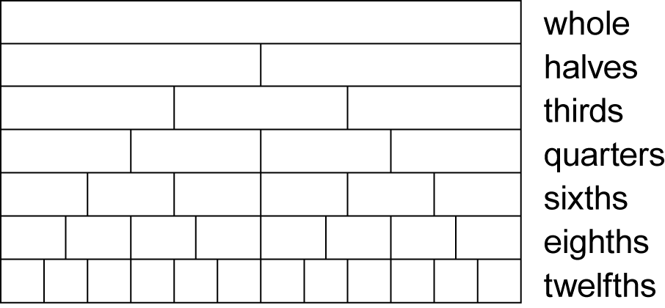  - model, compare and represent fractions with denominator of 2, 3, 4, 5, 6, 8, 10, 12 and 100 of a whole object, a whole shape and a collection of objects  - compare the relative size of fractions drawn on the same diagram, eg  (Reasoning)  - compare and order simple fractions with related denominators using strategies such as diagrams, the number line, or equivalent fractions, eg write 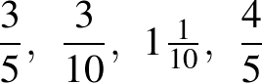 and 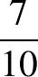 in ascending order | Learning Intention:  Success Criteria:  Tasks:
2 | Compare fractions with related denominators and locate and represent them on a number line (ACMNA125)  - find equivalent fractions by re-dividing the whole, using diagrams and number lines, eg  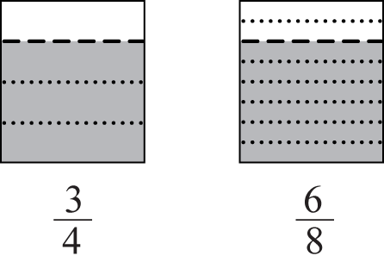  - record equivalent fractions using diagrams and numerals  - develop mental strategies for generating equivalent fractions, such as multiplying or dividing the numerator and the denominator by the same number,  eg 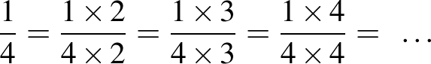, ie 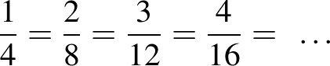  - explain or demonstrate why two fractions are or are not equivalent (Communicating, Reasoning) | Learning Intention:  Success Criteria:  Tasks:
3 | Compare fractions with related denominators and locate and represent them on a number line (ACMNA125)  - write fractions in their 'simplest form' by dividing the numerator and the denominator by a common factor, eg 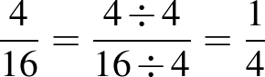  - recognise that a fraction in its simplest form represents the same value as the original fraction (Reasoning)  - apply knowledge of equivalent fractions to convert between units of time, eg 15 minutes is the same as 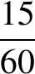 of an hour, which is the same as of an hour (Problem Solving) | Learning Intention:  Success Criteria:  Tasks:
4 | Solve problems involving addition and subtraction of fractions with the same or related denominators (ACMNA126)  - add and subtract fractions, including mixed numerals, where one denominator is the same as, or a multiple of, the other, eg 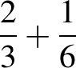, 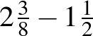, 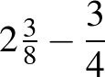  - convert an answer that is an improper fraction to a mixed numeral (Communicating)  - use knowledge of equivalence to simplify answers when adding and subtracting fractions (Communicating, Reasoning)  - recognise that improper fractions may sometimes make calculations involving mixed numerals easier (Communicating) | Learning Intention:  Success Criteria:  Tasks:
5 | Solve problems involving addition and subtraction of fractions with the same or related denominators (ACMNA126)  - solve word problems involving the addition and subtraction of fractions where one denominator is the same as, or a multiple of, the other, eg 'I ate of a cake and my friend ate of the cake. What fraction of the cake remains?'  - multiply simple fractions by whole numbers using repeated addition, leading to a rule,  eg 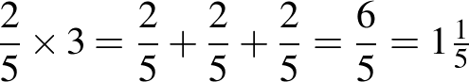 | Learning Intention:  Success Criteria:  Tasks:
6 | Solve problems involving addition and subtraction of fractions with the same or related denominators (ACMNA126)  Find a simple fraction of a quantity where the result is a whole number, with and without the use of digital technologies (ACMNA127)  - calculate unit fractions of collections, with and without the use of digital technologies, eg calculate of 30  - describe the connection between finding a unit fraction of a collection and the operation of division (Communicating, Problem Solving)  - calculate a simple fraction of a collection/quantity, with and without the use of digital technologies, eg calculate of 30  - explain how unit fractions can be used in the calculation of simple fractions of collections/quantities, eg 'To calculate of a quantity, I found of the collection first and then multiplied by 3' (Communicating, Reasoning)  - solve word problems involving a fraction of a collection/quantity | Learning Intention:  Success Criteria:  Tasks:
Summative Evaluation
- Were the program outcomes achieved?
- Were the activities relevant and appropriate to the needs of the students?
- What teaching strategy was most effective?
- Did students enjoy the program?
- Were there sufficient challenging opportunities for extension?
- What would I change next time?

Teaching and Learning Program: Volume and Capacity 2a
Outcomes  - MA3-1WM describes and represents mathematical situations in a variety of ways using mathematical terminology and some conventions  - MA3-2WM selects and applies appropriate problem-solving strategies, including the use of digital technologies, in undertaking investigations  - MA3-3WM gives a valid reason for supporting one possible solution over another  - MA3-11MG selects and uses the appropriate unit to estimate, measure and calculate volumes and capacities, and converts between units of capacity | Selecting appropriate units to measure volume and capacity  Converting between cubic centimetres/meters to millilitres/litres  Recognising equivalence between whole number and decimal notation for measurement of capacity  Recording measurements of volume and capacity
Mathematical Language: Students should be able to communicate using the following language: capacity, container, litre, millilitre, volume, dimensions, length, width, height, layers, cubic centimetre, cubic metre.

 | Content | Lessons (embed resources) | Differentiation | Annotations/ Evidence of Learning | Reg
1 | Connect volume and capacity and their units of measurement (ACMMG138)  - select the appropriate unit to measure volume and capacity  - demonstrate that a cube of side 10 cm will displace 1 litre of water  - demonstrate, by using a medicine cup, that a cube of side 1 cm will displace 1 mL of water  - equate 1 cubic centimetre to 1 millilitre and 1000 cubic centimetres to 1 litre  - find the volumes of irregular solids in cubic centimetres using a displacement strategy | Learning Intention:  Success Criteria:  Tasks:
2 | Connect decimal representations to the metric system (ACMMG135)  - recognise the equivalence of whole-number and decimal representations of measurements of capacities, eg 375 mL is the same as 0.375 L  - interpret decimal notation for volumes and capacities, eg 8.7 L is the same as 8 litres and 700 millilitres  - record volume and capacity using decimal notation to three decimal places, eg 1.275 L | Learning Intention:  Success Criteria:  Tasks:
3 |  | Learning Intention:  Success Criteria:  Tasks:

Summative Evaluation
- Were the program outcomes achieved?
- Were the activities relevant and appropriate to the needs of the students?
- What teaching strategy was most effective?
- Did students enjoy the program?
- Were there sufficient challenging opportunities for extension?
- What would I change next time?

.

Teaching and Learning Program: Position 1a
Outcomes  - MA3-1WM describes and represents mathematical situations in a variety of ways using mathematical terminology and some conventions  - MA3-17MG locates and describes position on maps using a grid-reference system |  |  | Locating position on map using grid reference  Describing location on map using grid reference  Describing routes using landmarks and directions  Describing directions of locations in relation to another
Mathematical Language: Students should be able to communicate using the following language: position, location, map, plan, street directory, route, grid, grid reference, legend, key, scale, directions, compass, north, east, south, west, north-east, south-east, south-west, north-west
 | Content | Lessons (embed resources) |  | Differentiation | Annotations/ Evidence of Learning | Reg
1 | Use a grid-reference system to describe locations (ACMMG113)  - find locations on maps, including maps with legends, given their grid references  - describe particular locations on grid-referenced maps, including maps with a legend, eg 'The post office is at E4' | Learning Intention:  Success Criteria:  Tasks:
2 | Describe routes using landmarks and directional language (ACMMG113)  - find a location on a map that is in a given direction from a town or landmark, eg locate a town that is north-east of Broken Hill  - describe the direction of one location relative to another, eg 'Darwin is north-west of Sydney' | Learning Intention:  Success Criteria:  Tasks:

Summative Evaluation
- Were the program outcomes achieved?
- Were the activities relevant and appropriate to the needs of the students?
- What teaching strategy was most effective?
- Did students enjoy the program?
- Were there sufficient challenging opportunities for extension?
- What would I change next time?

Teaching and Learning Program: Data 2a
Outcomes  - MA3-1WM describes and represents mathematical situations in a variety of ways using mathematical terminology and some conventions  - MA3-3WM gives a valid reason for supporting one possible solution over another  - MA3-18SP uses appropriate methods to collect data and constructs, interprets and evaluates data displays, including dot plots, line graphs and two-way tables | Summary and assessment overview  Creating and interpreting data in two way tables  Interpreting side by side graphs for categorical variables  Interpreting and comparing different displays of same data
Mathematical Language Students should be able to communicate using the following language: data, collect, category, display, table, column graph, scale, axes, two-way table, side-by-side column graph, misleading, bias.

 | Content | Lessons (embed resources) | Differentiation | Annotations/ Evidence of Learning | Reg
1 | Interpret and compare a range of data displays, including side-by-side column graphs for two categorical variables (ACMSP147)  - interpret data presented in two-way tables  - create a two-way table to organise data involving two categorical variables, eg  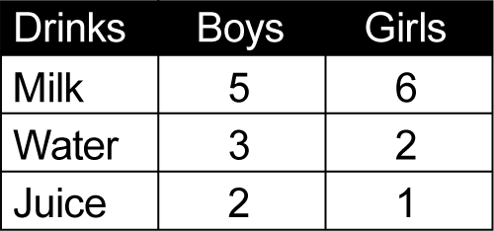 | Learning Intention:  Success Criteria:  Tasks:
2 | Interpret and compare a range of data displays, including side-by-side column graphs for two categorical variables (ACMSP147)  - interpret side-by-side column graphs for two categorical variables, eg favourite television show of students in Year 1 compared to that of students in Year 6 | Learning Intention:  Success Criteria:  Tasks:
3 | Interpret and compare a range of data displays, including side-by-side column graphs for two categorical variables (ACMSP147)  - interpret and compare different displays of the same data set to determine the most appropriate display for the data set  - compare the effectiveness of different student-created data displays (Communicating)  - discuss the advantages and disadvantages of different representations of the same data (Communicating)   - explain which display is the most appropriate for interpretation of a particular data set (Communicating, Reasoning)  - compare representations of the same data set in a side-by-side column graph and in a two-way table (Reasoning) | Learning Intention:  Success Criteria:  Tasks:
Summative Evaluation
- Were the program outcomes achieved?
- Were the activities relevant and appropriate to the needs of the students?
- What teaching strategy was most effective?
- Did students enjoy the program?
- Were there sufficient challenging opportunities for extension?
- What would I change next time?

Teaching and Learning Program: Angles 2a
Outcomes  - MA3-1WM describes and represents mathematical situations in a variety of ways using mathematical terminology and some conventions  - MA3-16MG measures and constructs angles, and applies angle relationships to find unknown angles | Summary and assessment overview  Identifying and naming angle types  Investigating adjacent angles and angles at a point  Using established dimensions to find size of unknown angles
Mathematical Language Students should be able to communicate using the following language: angle, right angle, straight angle, angles on a straight line, angle of revolution, angles at a point, vertically opposite angles.

 | Content | Lessons (embed resources) | Differentiation | Annotations/ Evidence of Learning | Reg
1 | Investigate, with and without the use of digital technologies, angles on a straight line, angles at a point, and vertically opposite angles; use the results to find unknown angles (ACMMG141)  - identify and name angle types formed by the intersection of straight lines, including right angles, 'angles on a straight line', 'angles at a point' that form an angle of revolution, and 'vertically opposite angles'  - recognise right angles, angles on a straight line, and angles of revolution embedded in diagrams (Reasoning)  - identify the vertex and arms of angles formed by intersecting lines (Communicating)  - recognise vertically opposite angles in different orientations and embedded in diagrams (Reasoning) | Learning Intention:  Success Criteria:  Tasks:
2 | Investigate, with and without the use of digital technologies, angles on a straight line, angles at a point, and vertically opposite angles; use the results to find unknown angles (ACMMG141)  - investigate, with and without the use of digital technologies, adjacent angles that form a right angle and establish that they add to 90°  - investigate, with and without the use of digital technologies, adjacent angles on a straight line and establish that they form a straight angle and add to 180°  - investigate, with and without the use of digital technologies, angles at a point and establish that they form an angle of revolution and add to 360° | Learning Intention:  Success Criteria:  Tasks:
3 | Investigate, with and without the use of digital technologies, angles on a straight line, angles at a point, and vertically opposite angles; use the results to find unknown angles (ACMMG141)  - use the results established for adjacent angles that form right angles, straight angles and angles of revolution to find the size of unknown angles in diagrams  - explain how the size of an unknown angle in a diagram was calculated (Communicating, Reasoning)  - investigate, with and without the use of digital technologies, vertically opposite angles and establish that they are equal in size  - use the equality of vertically opposite angles to find the size of unknown angles in diagrams | Learning Intention:  Success Criteria:  Tasks:
Summative Evaluation
- Were the program outcomes achieved?
- Were the activities relevant and appropriate to the needs of the students?
- What teaching strategy was most effective?
- Did students enjoy the program?
- Were there sufficient challenging opportunities for extension?
- What would I change next time?

Teaching and Learning Program: Revision
Outcomes | Summary and assessment overview
Mathematical Language Students should | Summary and assessment overview

 | Content | Lessons (embed resources) | Differentiation | Annotations/ Evidence of Learning | Reg
1 |  | Learning Intention:  Success Criteria:  Tasks:
2 |  | Learning Intention:  Success Criteria:  Tasks:
3 |  | Learning Intention:  Success Criteria:  Tasks:
4 |  | Learning Intention:  Success Criteria:  Tasks:
5 |  | Learning Intention:  Success Criteria:  Tasks:
Summative Evaluation
- Were the program outcomes achieved?
- Were the activities relevant and appropriate to the needs of the students?
- What teaching strategy was most effective?
- Did students enjoy the program?
- Were there sufficient challenging opportunities for extension?
- What would I change next time?

