PARENT VOLUNTEERS

INDUCTION PACK
2023

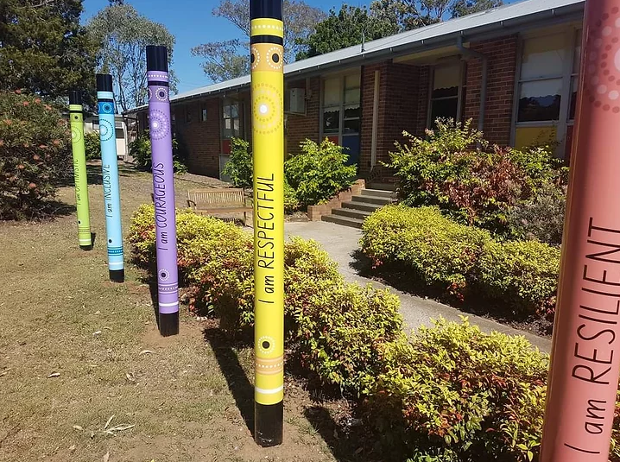

Welcome to Richmond North Public School. Thank you for your contribution to the school community and your willingness to help at the school. It is most valued by teachers and children and contributes to the overall education of children at our school.

Rationale
Richmond North Public School acknowledges and appreciates any support afforded to it by volunteers. We greatly value the support of the school community in assisting in providing an excellent education for our students.


Guidelines For Class Volunteers

- The classroom teacher is responsible for the education and behaviour management of the children at all times. The volunteer is a helper, working under his/her direction and should refer any concerns directly to the teacher.
- The classroom teacher is the professional and facilitates the learning. The school expects volunteers to respect the teacher’s expertise and maintain a professional attitude as they work alongside the teacher. The importance of maintaining confidentiality is vital, therefore volunteers must not discuss the classroom, events, and/or “children” outside the class or school.
- Teachers are entrusted with the development of a whole class of children and must be equitable to all. We ask that volunteers also provide confidentiality, support, and equal opportunities for all children in the class. Please be respectful of all students’ privacy related to their class work.
- Encourage children to be independent and to try activities before we help or provide answers to them.
- Let the classroom teacher know if a child discusses a matter that concerns you.


Confidentiality
Confidentiality is extremely important. Volunteers are in a position of trust and should not discuss with any other parent, child, friend or neighbour any information concerning students, staff or any other parent. It is very important to treat anything you hear or see in school with regard to individual children as being in confidence and entirely a school matter. Any conversations with parents outside of the school is a breach of the school, child and/or staff members confidence. If a parent asks you about children, you are working with please direct them to the class teacher. If volunteers have a concern or issue, they are encouraged to raise this concern with the class teacher, Assistant Principal, or the Principal. At no time is a volunteer permitted to film or photograph any child without the consent of the supervising teacher and should be carried out for educational purposes. Filming or photographing any child or writing information about students or the school on social media will be considered a breach of confidentiality.
As schools are mandatory reporters with the Department of Community and Justice, any disclosures by students to volunteers must be reported to the class teacher or the Principal.
Please understand any volunteer helper not fulfilling these requirements may be requested to withdraw from helping at our school.

Health and Safety
- To meet a variety of Health and Safety regulations, it is very important that we know exactly who is on the school premises and where they are. We therefore ask every volunteer who comes into the school goes via the school office.
- Volunteers must first sign in the visitor’s book and at the end of the session it is necessary to return to the office and sign out.
- For your own protection/safety we ask that classroom helpers do not enter the classroom unless the teacher is present.
- We ask that mobile phones are put on silent or switched off and not used while in the classroom.
- For the safety and learning of the children in the class we ask not to bring younger siblings.
- All people doing work on school sites that involves direct interaction with students, who are not employed by the department, must also be double-vaccinated. This includes volunteers and is enforced through a Department Work Health and Safety policy directive.


Induction
All volunteers must have completed the Induction session each year, before being able to help in the classroom.

Declaration form
All volunteers are required to complete a Declaration for Child-Related workers form and give the the office staff.

Absence
Volunteers are asked to telephone the school if they cannot come into school when expected or to notify the teacher prior.

Emergency Evacuation Plan
Volunteers are asked to familiarise themselves with the emergency evacuation plan in the classroom in case of an emergency. It is important that the helper stay with the teacher and evacuate the room with the class and go directly to the designated area.

Supervision
It is important that a teacher is always with you when you are with children. The teacher is required to always maintain a visual line of sight with you and the children. No volunteer will be left unsupervised with children and should avoid any unnecessary physical contact with students. There are times when you may need to touch a student; for example, if they have fallen over and need assistance standing up.

Physical Contact
It is important to remember that as a volunteer you are seen as another professional within our school community so it is expected that you act in a professional manner at all times.



Overall Expectations for Volunteers in the Classroom

- Be aware you may not be working with your own child.
- Give all children equal time and attention where possible.
- Understand that children have different needs and complete work at different rates and levels of ability.
- The teacher is responsible for the programs operating in the classroom.
- The teacher is in charge and have responsibility for the safety, welfare and care of the students.
- Volunteers are not to bring younger siblings or children due to health and safety reasons and to minimise disruptions to the learning of students.
- Parent/carer conduct should at all times be calm, respectful and encouraging as an appropriate model for students.
- Any learning or behaviour concerns will be reported to and managed by the classroom teacher or Assistant Principal if required.
- Please ensure there is no smoking. Schools are strictly non-smoking venues and smoking is not permitted within 10 metres of school boundaries.
- Parents/carers should not consume or have consumed alcohol, or be under the influence of any drugs prior to working with children.
- All volunteers need to complete a current Working with Children Check and/or a Declaration for Child Related Workers form and have submitted this information to the office prior to working in the school.
- Volunteers need to sign in and sign out every time they assist the teacher in the class in the visitor book in the office.
- Volunteers should cooperate with teachers in charge to ensure safety and welfare of students.
- Refrain from unnecessary conversations with other adults whilst students are working.
- Volunteers to respect confidentiality and privacy at all times.
- To be supportive of the teachers/other volunteers and ability to work positively as part of a team.
- Report any concerns or disclosures to the Stage AP or Principal as soon as is practical.
- Dress appropriately

When you volunteer in the classroom you have the right to:

- Be thanked and appreciated by the teacher and students
- Work in a safe environment
- Have your privacy protected
- Be supported by the teacher in your role
- Have feedback from the teacher
- Be kept informed about any changes to your routine
- Be covered by personal liability

Thank you for your contribution to the school community and your willingness to help at the school. It is most valued by teachers and children and contributes to the overall education of children at our school.

