|  |  |  |  |  |  |
| --- | --- | --- | --- | --- | --- |
| Number Strand Program | | | | | |
|  | Concept | Stage | Teacher | Term | Week |
| **Maths** | **Multiplication** | **ES1** | **Miss Ziesel** | **2** | **4** |



|  |  |  |  |  |
| --- | --- | --- | --- | --- |
| Outcomes | | | Content | |
| **MAE-WM-01**  develops understanding and fluency in mathematics through exploring and connecting mathematical concepts, choosing and applying mathematical techniques to solve problems, and communicating their thinking and reasoning coherently and clearly  **MAE-FG-02**  forms equal groups by sharing and counting collections of objects | | | * Model equal groups and use terminology: group | |
| Lesson Overview | | | Reg | Mathematical Language |
| **Lesson 1** | **Equal Groups 1** | |  | Students should be able to communicate using the following language: **group**, **share**,**equal**. |
| **Lesson 2** | **Equal and Not Equal Groups** | |  |
| **Lesson 3** | **Equal Groups 2** | |  |
| Resources | | Teaching and Learning Sequence | | | |
| SMART  Notebook or PowerPoint File “Term 2 Week 4 Multiplication Kinder Maths”.  Counters, linking cubes, two hoops, collections of items, **BLM 1** (Ordering Cards), paper cups  **BLM 2** | | **Lesson 1: Equal Groups 1**  **Focus:** Compare collections to see if they have the same number.  ***Ignition Activity***  **Students play a game of ‘Match It’ with a partner and collections of three counters or linking cubes each. Player A hides some of the pieces on the table under a sheet of paper. Player B also covers some pieces. The pair then uncover each other’s collections and see it they are the same. Students may be able to readily see that the collections are the same or not, or may have to count each collection, or may line the collection up side by side.**  ***Activity***   * Seat students in a circle. Place two hoops on the floor in the centre. In one hoop, place a handful of counters of one colour and in the other hoop, place a handful of counters of another colour. Ask students to say if they think there are the same number of counters in each hoop. Discuss strategies to find out if the collections are the same or not. Try suggested strategies, including matching the counters one-to-one. Repeat three or four times for different handfuls of counters. * Repeat the above activity but substitute linking cubes for one pile of counters so that students compare the numbers from two different types of collections. * In small groups, give students a set of cards from **BLM 1** (Ordering Cards). Review how to play the game of ‘Concentration’. Lay out the cards face down. Students take it in turns to turn two cards over; if they match, they keep the cards and have another turn. This continues until all the cards are gone. They player with the most cards at the game’s end is the winner. * Students work in groups of four with 20 cubes. They make bars of cubes that are the same colour. They then line the bars up side by side to compare them. Encourage groups to make statements about the bars, such as: *The red bar has the most cubes. The green and pink bars have the same number of cubes.* * Have students work independently to complete **BLM 2**.   ***Support Activities***   * In pairs, one student puts out a row of items. The other student has to match this row with different items. * Students work I pairs. Each student takes a handful from different collections. They match them one-to-one to see who has more.   ***Extension Activities***   * Students in groups hide up to four counters under each of the eight upside-down paper cups, making sure that there are two of each number. Students take turns to try to find two cups with the same number. | | | |
| Resources | | Teaching and Learning Sequence | | | |
|  | | ***Reflection***  Discuss ways students compared two collections – lining items up side by side or counting. Choose students to demonstrate both methods.  ***ASSESSMENT***   * Can students recognise when two different collections have the same number of items? * Can students draw a collection with the same number as a given collection? | | | |
| SMART  Notebook or PowerPoint File “Term 2 Week 4 Multiplication Kinder Maths”.  Collection of items, linking cubes, scissors, drawing paper, counters  **BLM 3 (**Equal/ not equal cards)  **BLM 4** | | **Lesson 2: Equal and Not Equal Groups**  **Focus:** Compare and describe groups.  ***Ignition Activity***  **Students work in pairs. Each student takes up to five items from the collection without the other seeing. Students match their items one-to-one to compare groups. Ask various pairs to describe their groups. For example: *I have more than Tom. Kelly has the same as me. Tran and mine are equal. Ben has less than me.***  ***Activity***   * Choose two students to each take a handful of cubes and join them together. Students compare bars of cubes to see if they are the same or different/equal or not equal. Repeat for other pairs of students. * In pairs, students place one hand behind their back and face each other. Without discussion, students decide how many fingers to hold up and when both students are ready, they hold their hand up in front of them to show the number of fingers. Ask: *Do you have the same (equal) number of fingers held up or a different (not equal) number?* * Give pairs a copy of **BLM 3** (Equal/ not equal cards). Pairs cut out the cards, mix them up and take six each, which they hold face down. Use the cards to play a game of ‘Snap’. If two cards show the same number of items, the first student to place their hand over them and say *Snap* takes all the cards under their hand. * Place all the cards from the copies of **BLM 3** in one container. Divide the class into two teams. In turn, one student from each team takes a card and compares them. If cards have equal numbers, teams score one point each. If they’re not equal, the team with the card that has more scores one point. The winner is the team with the most points when all the cards are gone. * Have students independently complete **BLM 4.**   ***Support Activities***   * Give pairs of students plenty of opportunity to compare handfuls of different items by matching one-to-one. Ask questions such as: *Do you have an equal number of items? Who has more?* Encourage students to use the language comparison.   ***Extension Activities***   * Students work in groups of three or four to compare and order groups of items from a student who has the most to the student who has the least. * Students make their own ‘Snap’ cards similar to those on **BLM 3**.   ***Reflection***  Seat students in a circle. Choose two students to each take some counters and match them. Discuss if the groups are equal or not equal. Ask: *How do you know?* Repeat for other students.  ***ASSESSMENT***   * Are students able to identify groups that are equal? * Do students use the language of comparison appropriately? | | | |
| Resources | | Teaching and Learning Sequence | | | |
| SMART  Notebook or PowerPoint File “Term 2 Week 4 Multiplication Kinder Maths”.  Cards with numbers (1-6) **BLM 5** on them, dice, counters, paper plates, A4 paper, tins, sticks, string, beads  **BLM 6** | | **Lesson 3: Equal Groups 2**  **Focus:** Make and describe equal groups.  ***Ignition Activity***  **Place three paper plates on a table. Ask three students to stand behind a plate and put three counters on their plate. Ask: How many plates are there? (3) How many counters on each plate? (3) So there are three groups of three. Repeat for three groups of four, two groups of five, four groups of two, four groups of four.**  ***Activity***   * As a class, play a game of ‘Make this group’. Place a pile of cards with the numbers 1 to 6 on them (**BLM 5**) in the middle of a circle of students.   Students then take it in turns to take a card from the top of the pile. This card will determine what number of groups we are talking about. Then have the student roll a dice to decide how many will be in each group. For example, if students turn over a card labelled 4 and roll a 3, they have to make four groups of three.  All students can then use counters to make up the groups as stated by the student who did the rolling and turning.   * Have each student fold an A4 piece of paper into quarters and draw along the fold lines. Each ‘box’ can have one group of counters. Show students how to make two groups of three, then three groups of three, then four groups of three, then one group of three, with students modelling what you do with the counters.   Give some other examples and have students show the groups on their paper.   * Have students independently complete **BLM 6.**   ***Support Activities***   * Students work with paper plates and counters, and tins and sticks to make equal groups. For example, say: *Put four sticks in each of two tins; Put five counters on each of three plates.*   ***Extension Activities***   * Students make strings of beads using groups of two, three or four and count how many groups.   ***Reflection***  Ask students to describe the groups on their own body: four groups of five (fingers and toes), two groups of two (ears and eyes), etc.  ***ASSESSMENT***   * Can students make equal groups? * Can students describe equal groups? | | | |
| Additional Activities | | | | | |
| * **Groups of Children:** Students skip within a given area. Teacher calls out a number and students make groups of that number. Possible questions:   + - do all groups have the same number of students?     - how can we check this?     - Students line up in rows so the groups can be compared. * **Number Problems:** Teachers and students can use current topics of study as a setting for number problems eg if the students are looking at the life cycle of lizards, the teacher might pose the question ‘If four lizards each laid four eggs, how many eggs would there be?’ * **Same Number of Groups:** Students are asked to make 4 groups of two objects. It may help to have four pieces of paper or a large sheet marked with four squares. Possible questions:   + - can you replace the four groups of two with four groups of another size?     - can you describe your new groups? | | | | | |
| * **Farms:** In groups, students are given a place mat with three, four or five ovals on it to represent paddocks. They are also given a collection of plastic animals. Student A rolls a die and all the students place that number of animals in each paddock. Each student is asked to describe their farm and is encouraged to use numbers in their description. Students record their findings. (Adapted from CMIT) * **Pasting Rows:** Students cut and paste pictures to create arrays. They are asked to describe their array and use numerals/words to label its features. Possible questions include:   + - is there a different way to make this group?     - what new groups can be made with the same objects?     - how could you check your answer? * **Spotty Henry:** The teacher presents the following story: Henry is a spotted octopus with 8 legs. He has 2 spots on each leg. How many spots does Henry have?’ Materials are provided for students to work out a way to solve and record the problem. *Extension:* Students create and illustrate their own story for others to solve. | | | | | |

BLM 1

|  |  |
| --- | --- |
|  |  |
|  |  |
|  |  |
|  |  |

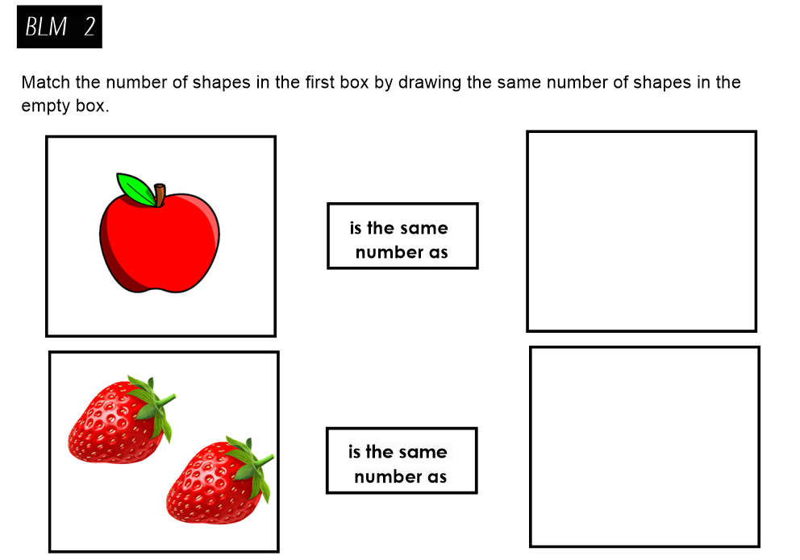 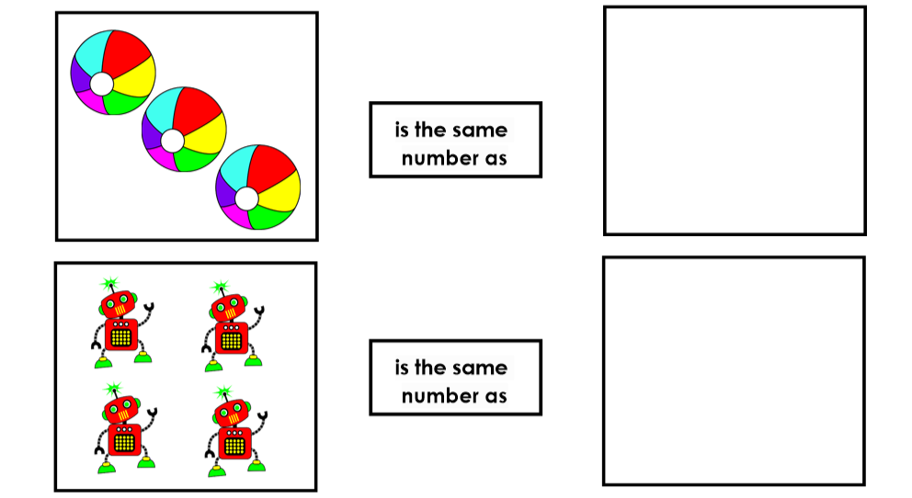

BLM 3

|  |  |  |
| --- | --- | --- |
|  |  |  |
|  |  |  |
|  |  |  |
|  |  |  |

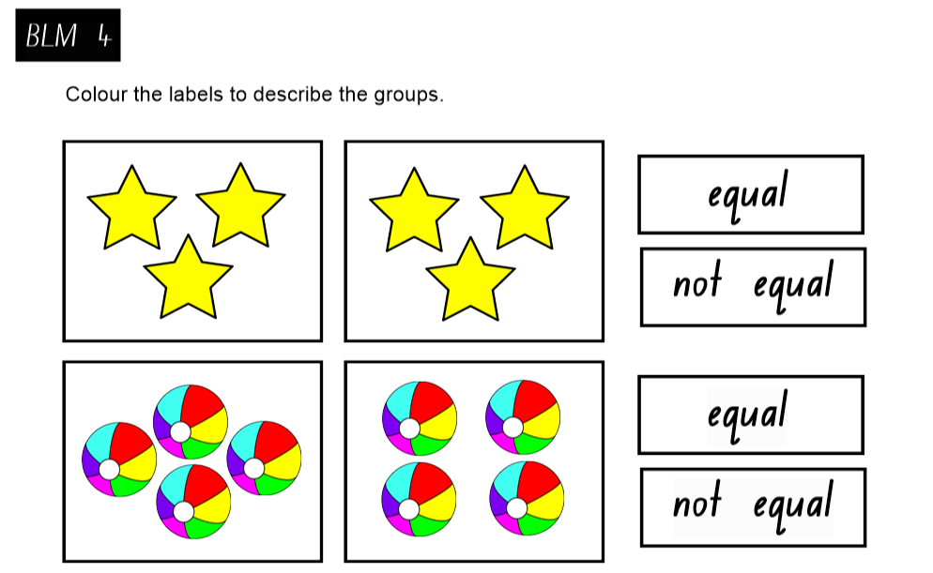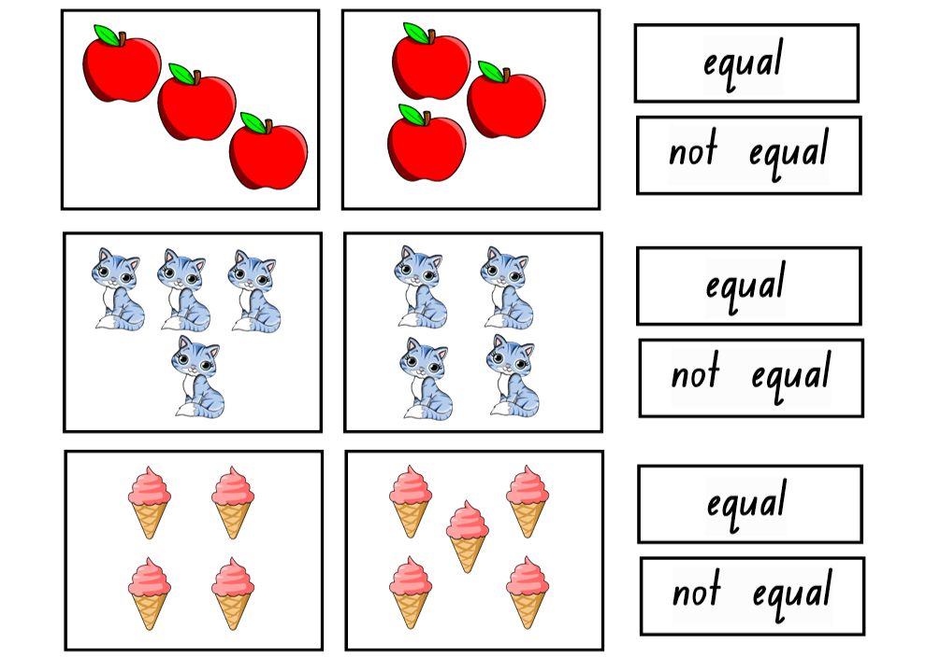

BLM 5

|  |  |  |
| --- | --- | --- |
|  |  |  |
|  |  |  |
| 1 | 2 | 3 |
| 4 | 5 | 6 |

