Stage 2 - Working From Home - Floods Wednesday 9th March 2022
Tuesday, 8 March 2022
2:37 PM
Stage 2 (3/4C, 3/4D, 4/5J) - Wednesday 9/3/22- Working from Home

Hi everyone,
We hope you are all doing well and that you haven't lost anything or had any damage during this rain period.
As yesterday, we are non-operational today, however today we have some work set for you to do.
Please complete as much as you can and contact your teacher if you have any difficulties.

Thinking of you all,
Stage 2 and Stage 3 teachers.

English
Reading
Read a couple of chapters from a book you have at home and answer the following in full sentence answers.  - What is the name of your book?  - How many pages have you read this morning?  - Who is the main character in your book?  - Would you recommend this book to a friend? Why/why not? | Draw your book cover. Remember the title, author and illustrator.

Spelling
  - Using your spelling words create 3 sentences. Remember to use correct punctuation and grammar.
  - Select 5 of your spelling words and either draw them or find a picture on the internet.

Year 3 Spelling Words:

Year 4 Spelling Words:

Spelling Sentences:

Spelling pictures:

Writing

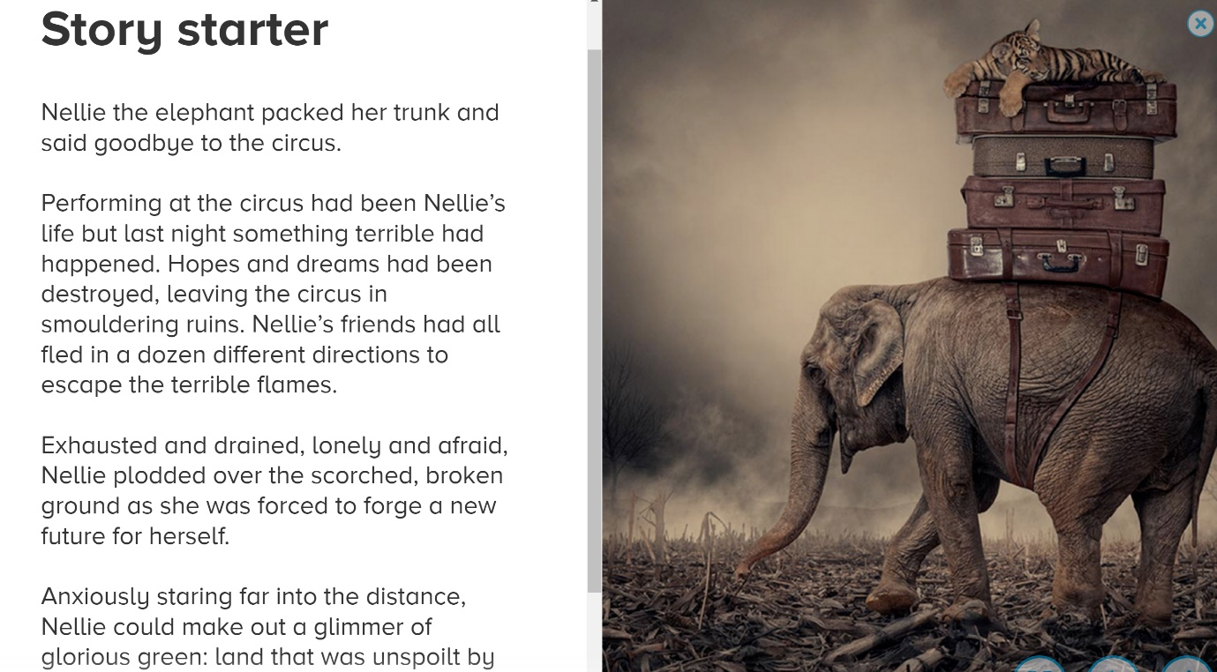


Comprehension Activity
Please complete the activity you are most comfortable with. You can either complete the Superhero Joey activity or The Haunted Tree. Tree.

Mathematics Activity
Log in to your Mathletics using the link - https://login.mathletics.com/

There is assigned work from your teacher, try your best and if you need help ask your teacher.

Mathematics Act

Creative Arts Activity
How to draw a dragon silhouette - How To Draw A Dragon Silhouette

You'll need a pencil, rubber and some paper.

Watch and follow along the clip to draw a dragon.

