Maths Term 2 Stage 3 – Year 5 - 2020
Duration: 10 weeks – 5x 1hr lessons per week |  | Prior Knowledge: Insert expected prior knowledge here
Unit Description and Organisation  During each unit, students will explore skills for working mathematically as they engage in content. Students are taught specific skills and strategies for each content area. Students will be provided with opportunities to manipulate concrete materials as they develop mathematical knowledge. |  | Links to other KLAs  - English – language  - Science - 3D space – things that move  - Creative Arts – Patterns with sounds |  |  | Each unit of work will incorporate formative and summative assessment:  Formative assessment:  - Observation notes/anecdotal records as lesson annotations. This may also include formative assessments as lesson sequence (as indicated)  Summative assessment:  - Grade assessment to be completed at the end of each unit- this will be included in the lesson program and may be completed during rotations or as whole class.
Quality Teaching Framework | Intellectual Quality  Deep knowledge - Deep understanding - Problematic knowledge - Higher-order thinking – Metalanguage - Substantive communication |  | Quality Leaning Environment  Explicit quality criteria – Engagement - High expectations - Social support - Students’ self-regulation - Student direction |  |  | Significance  Background knowledge - Cultural knowledge - Knowledge integration – Inclusivity – Connectedness - Narrative
Learning Across the Curriculum | Literacy – Numeracy – Critical & creative thinking – Ethical understanding – Personal and social capabilities – Intercultural understanding – ICT – Sustainability – Aboriginal/Torres Strait Islanders histories and culture – Australia’s engagement with Asia – Difference & diversity – Civics & citizenship – Work & enterprise
Learning Progressions | Speaking & Listening  Listening – Interacting - Speaking |  |  | Reading & Viewing  Phonological awareness – Phonic knowledge and word recognition – Fluency – Understanding Texts - |  |  | Writing  Creating texts (informative/persuasive/imaginative) – Grammar – Punctuation – Spelling – Handwriting & keyboarding
 | Number Sense & Algebra  Quantifying numbers – Additive strategies – Multiplicative strategies – Operating with decimals – Operating with percentages – understanding money – Number patterns and algebraic thinking – Comparing units (ratios/rates/proportion) – Interpreting fractions |  |  | Measurement & Geometry  Understanding units of measurement – Understanding geometric properties – Positioning & locating – Measuring time |  |  | Statistics & Probability  Understanding chance – Interpreting & representing data

.

.

Term 2 Scope and Sequence (Year 5)
Multiplication and Division 1a | Area 1a | 2D Space 1a | Fractions and Decimals 1a | Volume and Capacity 1a | Position 1a | Data 1a | Angles 1a | Revision
5-6 lessons and assessment | 3-4 lessons and assessment | 3-4 lessons and assessment | 5 lessons and assessment | 3 lessons and assessment | 2-3 lessons and assessment | 4-5 lessons and assessment | 3-4 lessons and assessment
MA3-1WM, MA3-2WM, MA3-3WM, MA3-6NA | MA3-1WM, MA3-10MG | MA3-1WM, MA3-2WM, MA3-3WM, MA3-15MG | MA3-1WM, MA3-2WM, MA3-3WM, MA3-7NA | MA3-1WM, MA3-3WM, MA3-11MG | MA3-1WM, MA3-17MG | MA3-1WM, MA3-3WM, MA3-18SP | MA3-1WM, MA3-16MG
Using written and mental strategies to multiply 3-4 digits by 2 digits (partitioning, area model, formal algorithm)  Using calculators to multiply numbers up to 4 digits  Appying appropriate multiplication strategies to solve word problems | Selecting appropriate units of measurement for area  Converting units of measurement for area  Determining the dimensions of different rectangles | Identifying, naming and describing triangles  Exploring properties of squares, rectangles, parallelograms and rhombuses  Identifying and drawing regular and irregular 2D shapes from descriptions | Placing fractions on a number line  Comparing and ordering fractions  Identifying and describing 'proper' and 'improper' fractions and mixed numerals  Modelling strategies to add and subtract proper fractions (same denominator)  Modelling strategies to add mixed numerals (same denominator)  Solving word problems to add and subtract fractions | Selecting and using appropriate units to measure capacity  Measuring volume of rectangular containers using cubic centimetres | Using grid references to find locations on maps  Describing locations on maps using grid references | Surveying and collecting data  Tabulating data and constructing graphs | Identifying arms and vertex of angles  Recognising need for formal measurement and recording measurements using the symbol for degrees  Measuring angles using protractor

Teaching and Learning Program: Multiplication and Division 1a
Outcomes  - MA3-1WM describes and represents mathematical situations in a variety of ways using mathematical terminology and some conventions  - MA3-2WM selects and applies appropriate problem-solving strategies, including the use of digital technologies, in undertaking investigations  - MA3-3WM gives a valid reason for supporting one possible solution over another  - MA3-6NA selects and applies appropriate strategies for multiplication and division, and applies the order of operations to calculations involving more than one operation | Summary and assessment overview  Using written and mental strategies to multiply 3-4 digits by 2 digits (partitioning, area model, formal algorithm)  Using calculators to multiply numbers up to 4 digits  Applying appropriate multiplication strategies to solve word problems
Mathematical Language: Students should be able to communicate using the following language: multiply, multiplied by, product, multiplication, multiplication facts, area, thousands, hundreds, tens, ones, double, multiple, factor, divide, divided by, quotient, division, halve, remainder, fraction, decimal, equals, strategy, digit, estimate, round to.

 | Content | Lessons (embed resources) | Differentiation | Annotations/ Evidence of Learning | Reg
1 | Solve problems involving multiplication of large numbers by one- or two-digit numbers using efficient mental and written strategies and appropriate digital technologies (ACMNA100)  - use mental and written strategies to multiply three- and four-digit numbers by one-digit numbers, including:   - multiplying the thousands, then the hundreds, then the tens and then the ones, eg  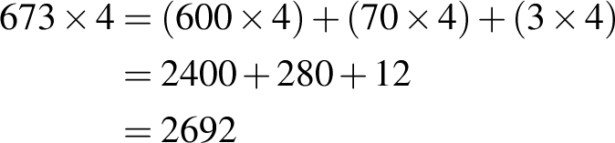  - using an area model, eg 684 × 5  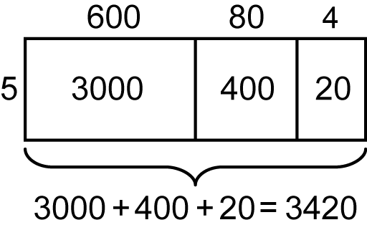 | Learning Intention:  Success Criteria:  Tasks:
2 | Solve problems involving multiplication of large numbers by one- or two-digit numbers using efficient mental and written strategies and appropriate digital technologies (ACMNA100)  - using the formal algorithm, eg 432 × 5  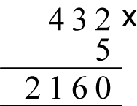 | Learning Intention:  Success Criteria:  Tasks:
3 | Solve problems involving multiplication of large numbers by one- or two-digit numbers using efficient mental and written strategies and appropriate digital technologies (ACMNA100)  use mental and written strategies to multiply two- and three-digit numbers by two-digit numbers, including:  - using an area model for two-digit by two-digit multiplication, eg 25 × 26  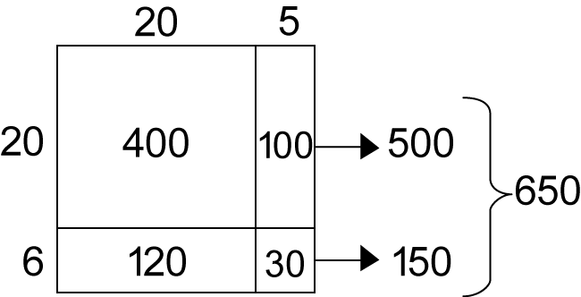  - factorising the numbers, eg 12 × 25 = 3 × 4 × 25 = 3 × 100 = 300  - using the extended form (long multiplication) of the formal algorithm, eg  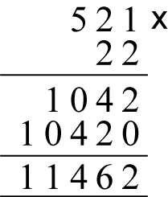 | Learning Intention:  Success Criteria:  Tasks:
4 | Solve problems involving multiplication of large numbers by one- or two-digit numbers using efficient mental and written strategies and appropriate digital technologies (ACMNA100)  - use digital technologies to multiply numbers of up to four digits   - check answers to mental calculations using digital technologies (Problem Solving) | Learning Intention:  Success Criteria:  Tasks:
5 | Solve problems involving multiplication of large numbers by one- or two-digit numbers using efficient mental and written strategies and appropriate digital technologies (ACMNA100)  - apply appropriate mental and written strategies, and digital technologies, to solve multiplication word problems   - use the appropriate operation when solving problems in real-life situations (Problem Solving)  - use inverse operations to justify solutions (Problem Solving, Reasoning)  - record the strategy used to solve multiplication word problems  - use selected words to describe each step of the solution process (Communicating, Problem Solving) | Learning Intention:  Success Criteria:  Tasks:
Summative Evaluation
- Were the program outcomes achieved?
- Were the activities relevant and appropriate to the needs of the students?
- What teaching strategy was most effective?
- Did students enjoy the program?
- Were there sufficient challenging opportunities for extension?
- What would I change next time?

Teaching and Learning Program: Area 1a
Outcomes  - MA3-1WM describes and represents mathematical situations in a variety of ways using mathematical terminology and some conventions  - MA3-10MG selects and uses the appropriate unit to calculate areas, including areas of squares, rectangles and triangles | Summary and assessment overview  Selecting appropriate units of measurement for area  Converting units of measurement for area  Determining the dimensions of different rectangles
Mathematical Language: Students should be able to communicate using the following language: area, measure, square centimetre, square metre, square kilometre, hectare, dimensions, length, width.

 | Content | Lessons (embed resources) | Differentiation | Annotations/ Evidence of Learning | Reg
1 | Choose appropriate units of measurement for area (ACMMG108)  - recognise the need for a formal unit larger than the square metre  - identify situations where square kilometres are used for measuring area, eg a suburb | Learning Intention:  Success Criteria:  Tasks:
2 | Choose appropriate units of measurement for area (ACMMG108)  - recognise and explain the need for a more convenient unit than the square kilometre  - recognise that there are 10 000 square metres in one hectare, ie 10 000 square metres = 1 hectare  - equate one hectare to the area of a square with side lengths of 100 m (Communicating)  - determine the dimensions of different rectangles with an area of one hectare (Problem Solving)  - relate the hectare to common large pieces of land, including courts and fields for sports (Reasoning)  - record areas using the abbreviations for square kilometres (km²) and hectares (ha) | Learning Intention:  Success Criteria:  Tasks:
Summative Evaluation
- Were the program outcomes achieved?
- Were the activities relevant and appropriate to the needs of the students?
- What teaching strategy was most effective?
- Did students enjoy the program?
- Were there sufficient challenging opportunities for extension?
- What would I change next time?

Teaching and Learning Program: 2D Space 1a
Outcomes  - MA3-1WM describes and represents mathematical situations in a variety of ways using mathematical terminology and some conventions  - MA3-2WM selects and applies appropriate problem-solving strategies, including the use of digital technologies, in undertaking investigations  - MA3-3WM gives a valid reason for supporting one possible solution over another  - MA3-15MG manipulates, classifies and draws two-dimensional shapes, including equilateral, isosceles and scalene triangles, and describes their properties | Summary and assessment overview  Identifying, naming and describing triangles  Exploring properties of squares, rectangles, parallelograms and rhombuses  Identifying and drawing regular and irregular 2D shapes from descriptions
Mathematical Language: Students should be able to communicate using the following language: shape, two-dimensional shape (2D shape), triangle, equilateral triangle, isosceles triangle, scalene triangle, right-angled triangle, quadrilateral, parallelogram, rectangle, rhombus, square, trapezium, kite, pentagon, hexagon, octagon, regular shape, irregular shape, features, properties, side, parallel, pair of parallel sides, opposite, length, vertex (vertices), angle, right angle, line (axis) of symmetry, rotational symmetry, order of rotational symmetry, translate, reflect, rotate, enlarge.

 | Content | Lessons (embed resources) | Differentiation | Annotations/ Evidence of Learning | Reg
1 | Classify two-dimensional shapes and describe their features  - manipulate, identify and name right-angled, equilateral, isosceles and scalene triangles  - recognise that a triangle can be both right-angled and isosceles or right-angled and scalene (Reasoning)  - compare and describe features of the sides of equilateral, isosceles and scalene triangles  - explore by measurement side and angle properties of equilateral, isosceles and scalene triangles | Learning Intention:  Success Criteria:  Tasks:
2 | Choose appropriate units of measurement for area (ACMMG108)  - Classify two-dimensional shapes and describe their features  - explore by measurement angle properties of squares, rectangles, parallelograms and rhombuses  - select and classify a two-dimensional shape from a description of its features  - recognise that two-dimensional shapes can be classified in more than one way, eg a rhombus can be more simply classified as a parallelogram (Communicating, Reasoning) | Learning Intention:  Success Criteria:  Tasks:
3 | Classify two-dimensional shapes and describe their features  - identify and draw regular and irregular two-dimensional shapes from descriptions of their side and angle properties  - use tools such as templates, rulers, set squares and protractors to draw regular and irregular two-dimensional shapes (Communicating, Problem Solving)  - explain the difference between regular and irregular shapes (Communicating)  use computer drawing tools to construct a shape from a description of its side and angle properties (Communicating, Problem Solving) | Learning Intention:  Success Criteria:  Tasks:
Summative Evaluation
- Were the program outcomes achieved?
- Were the activities relevant and appropriate to the needs of the students?
- What teaching strategy was most effective?
- Did students enjoy the program?
- Were there sufficient challenging opportunities for extension?
- What would I change next time?

Teaching and Learning Program: Fractions and Decimals 1a
Outcomes  - MA3-1WM describes and represents mathematical situations in a variety of ways using mathematical terminology and some conventions  - MA3-2WM selects and applies appropriate problem-solving strategies, including the use of digital technologies, in undertaking investigations  - MA3-3WM gives a valid reason for supporting one possible solution over another  - MA3-7NA compares, orders and calculates with fractions, decimals and percentages | Summary and assessment overview  Placing fractions on a number line  Comparing and ordering fractions  Identifying and describing 'proper' and 'improper' fractions and mixed numerals  Modelling strategies to add and subtract proper fractions (same denominator)  Modelling strategies to add mixed numerals (same denominator)  Solving word problems to add and subtract fractions
Mathematical Language: Students should be able to communicate using the following language: one-thousandth, fraction, numerator, denominator, mixed numeral, whole number, number line, proper fraction, improper fraction, decimal, decimal point, digit, place value, decimal places

 | Content | Lessons (embed resources) | Differentiation | Annotations/ Evidence of Learning | Reg
1 | Compare and order common unit fractions and locate and represent them on a number line (ACMNA102)  - place fractions with denominators of 2, 3, 4, 5, 6, 8, 10 and 12 on a number line between 0 and 1, eg  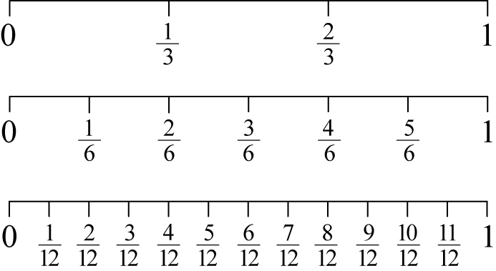  - compare and order unit fractions with denominators of 2, 3, 4, 5, 6, 8, 10, 12 and 100  - compare the relative value of unit fractions by placing them on a number line between 0 and 1 (Communicating, reasoning)  - investigate and explain the relationship between the value of a unit fraction and its denominator (Communicating, reasoning) | Learning Intention:  Success Criteria:  Tasks:
2 | Investigate strategies to solve problems involving addition and subtraction of fractions with the same denominator (ACMNA103)  - identify and describe 'proper fractions' as fractions in which the numerator is less than the denominator  - identify and describe 'improper fractions' as fractions in which the numerator is greater than the denominator  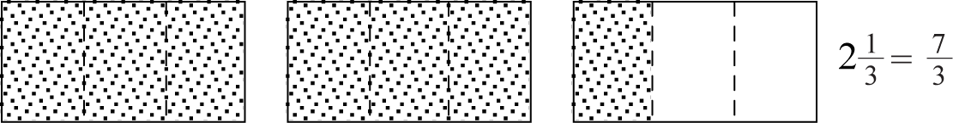  - express mixed numerals as improper fractions and vice versa, through the use of diagrams and number lines, leading to a mental strategy, eg | Learning Intention:  Success Criteria:  Tasks:
3 | Investigate strategies to solve problems involving addition and subtraction of fractions with the same denominator (ACMNA103)  - model and represent strategies, including using diagrams, to add proper fractions with the same denominator, where the result may be a mixed numeral, eg  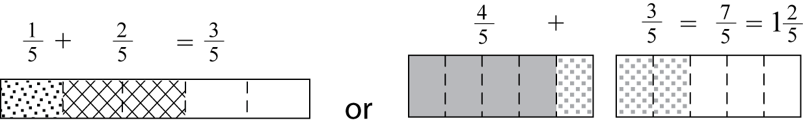  - model and represent a whole number added to a proper fraction, eg 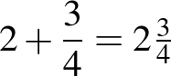  - subtract a proper fraction from another proper fraction with the same denominator, eg 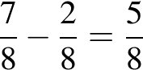 | Learning Intention:  Success Criteria:  Tasks:
4 | Investigate strategies to solve problems involving addition and subtraction of fractions with the same denominator (ACMNA103)  - model and represent strategies, including using diagrams, to add mixed numerals with the same denominator, eg  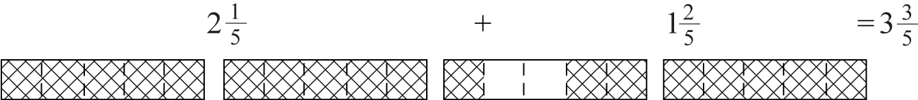  - use diagrams, and mental and written strategies, to subtract a unit fraction from any whole number including 1, eg  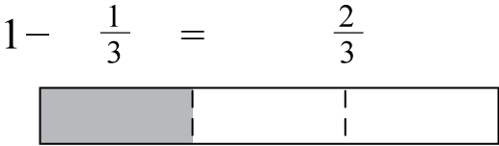  - solve word problems that involve addition and subtraction of fractions with the same denominator, eg 'I eat of a block of chocolate and you eat of the same block. How much of the block of chocolate has been eaten?'  - use estimation to verify that an answer is reasonable (Problem Solving, Reasoning) | Learning Intention:  Success Criteria:  Tasks:
Summative Evaluation
- Were the program outcomes achieved?
- Were the activities relevant and appropriate to the needs of the students?
- What teaching strategy was most effective?
- Did students enjoy the program?
- Were there sufficient challenging opportunities for extension?
- What would I change next time?

Teaching and Learning Program: Volume and Capacity 1a
Outcomes  - MA3-1WM describes and represents mathematical situations in a variety of ways using mathematical terminology and some conventions  - MA3-3WM gives a valid reason for supporting one possible solution over another  - MA3-11MG selects and uses the appropriate unit to estimate, measure and calculate volumes and capacities, and converts between units of capacity | Summary and assessment overview  Selecting and using appropriate units to measure capacity  Measuring volume of rectangular containers using cubic centimetres
Mathematical Language: Students should be able to communicate using the following language: capacity, container, volume, layers, cubic centimetre, cubic metre, measure, estimate.

 | Content | Lessons (embed resources) | Differentiation | Annotations/ Evidence of Learning | Reg
1 | Choose appropriate units of measurement for volume and capacity (ACMMG108)  - select and use appropriate units to measure the capacities of a variety of containers, eg millilitres for a drinking glass, litres for a water urn | Learning Intention:  Success Criteria:  Tasks:
2 | Choose appropriate units of measurement for volume and capacity (ACMMG108)  - measure the volumes of rectangular containers by packing them with cubic-centimetre blocks  - explain the advantages and disadvantages of using cubic-centimetre blocks as a unit to measure volume (Communicating, Reasoning)  - describe arrangements of cubic-centimetre blocks in containers in terms of layers, eg 5 layers of 8 cubic-centimetre blocks (Problem Solving) | Learning Intention:  Success Criteria:  Tasks:
Summative Evaluation
- Were the program outcomes achieved?
- Were the activities relevant and appropriate to the needs of the students?
- What teaching strategy was most effective?
- Did students enjoy the program?
- Were there sufficient challenging opportunities for extension?
- What would I change next time?

Teaching and Learning Program: Position 1a
Outcomes  - MA3-1WM describes and represents mathematical situations in a variety of ways using mathematical terminology and some conventions  - MA3-17MG locates and describes position on maps using a grid-reference system | Summary and assessment overview  Using grid references to find locations on maps  Describing locations on maps using grid references
Mathematical Language: Students should be able to communicate using the following language: position, location, map, plan, street directory, route, grid, grid reference, legend, key, scale, directions, compass, north, east, south, west, north-east, south-east, south-west, north-west.

 | Content | Lessons (embed resources) | Differentiation | Annotations/ Evidence of Learning | Reg
1 | Use a grid-reference system to describe locations (ACMMG113)  - find locations on maps, including maps with legends, given their grid references | Learning Intention:  Success Criteria:  Tasks:
2 | Use a grid-reference system to describe locations (ACMMG113)  - describe particular locations on grid-referenced maps, including maps with a legend, eg 'The post office is at E4' | Learning Intention:  Success Criteria:  Tasks:
Summative Evaluation
- Were the program outcomes achieved?
- Were the activities relevant and appropriate to the needs of the students?
- What teaching strategy was most effective?
- Did students enjoy the program?
- Were there sufficient challenging opportunities for extension?
- What would I change next time?

Teaching and Learning Program: Data 1a
Outcomes  - MA3-1WM describes and represents mathematical situations in a variety of ways using mathematical terminology and some conventions  - MA3-3WM gives a valid reason for supporting one possible solution over another  - MA3-18SP uses appropriate methods to collect data and constructs, interprets and evaluates data displays, including dot plots, line graphs and two-way tables | Summary and assessment overview  Surveying and collecting data  Tabulating data and constructing graphs
Mathematical Language: Students should be able to communicate using the following language: position, location, map, plan, street directory, route, grid, grid reference, legend, key, scale, directions, compass, north, east, south, west, north-east, south-east, south-west, north-west.

 | Content | Lessons (embed resources) | Differentiation | Annotations/ Evidence of Learning | Reg
1 | Pose questions and collect categorical or numerical data by observation or survey (ACMSP118)  - pose and refine questions to construct a survey to obtain categorical and numerical data about a matter of interest  - collect categorical and numerical data through observation or by conducting surveys, eg observe the number of a particular type of insect in one square metre of the playground over time | Learning Intention:  Success Criteria:  Tasks:
2 | Construct displays, including column graphs, dot plots and tables, appropriate for data type, with and without the use of digital technologies (ACMSP119)  - tabulate collected data, including numerical data, with and without the use of digital technologies such as spreadsheets  - construct column and line graphs of numerical data using a scale of many-to-one correspondence, with and without the use of digital technologies  - name and label the horizontal and vertical axes when constructing graphs (Communicating)  - choose an appropriate title to describe the data represented in a data display (Communicating)  - determine an appropriate scale of many-to-one correspondence to represent the data in a data display (Reasoning)  - mark equal spaces on the axes when constructing graphs, and use the scale to label the markers (Communicating) | Learning Intention:  Success Criteria:  Tasks:
3 | Construct displays, including column graphs, dot plots and tables, appropriate for data type, with and without the use of digital technologies (ACMSP119)  - construct dot plots for numerical data, eg the number of siblings of each student in the class  - consider the data type to determine and draw the most appropriate display(s), such as column graphs, dot plots and line graphs  - discuss and justify the choice of data display used (Communicating, Reasoning)  - recognise that line graphs are used to represent data that demonstrates continuous change, eg hourly temperature (Communicating)  recognise which types of data display are most appropriate to represent categorical data (Communicating) | Learning Intention:  Success Criteria:  Tasks:
Summative Evaluation
- Were the program outcomes achieved?
- Were the activities relevant and appropriate to the needs of the students?
- What teaching strategy was most effective?
- Did students enjoy the program?
- Were there sufficient challenging opportunities for extension?
- What would I change next time?

Teaching and Learning Program: Angles 1a
Outcomes  - MA3-1WM describes and represents mathematical situations in a variety of ways using mathematical terminology and some conventions  - MA3-16MG measures and constructs angles, and applies angle relationships to find unknown angles | Summary and assessment overview  Identifying arms and vertex of angles  Recognising need for formal measurement and recording measurements using the symbol for degrees  Measuring angles using protractor
Mathematical Language: Students should be able to communicate using the following language: angle, arm, vertex, protractor, degree.

 | Content | Lessons (embed resources) | Differentiation | Annotations/ Evidence of Learning | Reg
1 | Estimate, measure and compare angles using degrees (ACMMG112)  - identify the arms and vertex of an angle where both arms are invisible, such as for rotations and rebounds  - recognise the need for a formal unit for the measurement of angles  - record angle measurements using the symbol for degrees (°) | Learning Intention:  Success Criteria:  Tasks:
2 | Estimate, measure and compare angles using degrees (ACMMG112)  - measure angles of up to 360° using a protractor  - explain how a protractor is used to measure an angle (Communicating)  - explore and explain how to use a semicircular protractor to measure a reflex angle (Communicating, Reasoning)  - extend the arms of an angle where necessary to facilitate measurement of the angle using a protractor (Problem Solving) | Learning Intention:  Success Criteria:  Tasks:
Summative Evaluation
- Were the program outcomes achieved?
- Were the activities relevant and appropriate to the needs of the students?
- What teaching strategy was most effective?
- Did students enjoy the program?
- Were there sufficient challenging opportunities for extension?
- What would I change next time?

Teaching and Learning Program: Revision
Outcomes | Summary and assessment overview
Mathematical Language Students should | Summary and assessment overview

 | Content | Lessons (embed resources) | Differentiation | Annotations/ Evidence of Learning | Reg
1 |  | Learning Intention:  Success Criteria:  Tasks:
2 |  | Learning Intention:  Success Criteria:  Tasks:
3 |  | Learning Intention:  Success Criteria:  Tasks:
4 |  | Learning Intention:  Success Criteria:  Tasks:
5 |  | Learning Intention:  Success Criteria:  Tasks:
Summative Evaluation
- Were the program outcomes achieved?
- Were the activities relevant and appropriate to the needs of the students?
- What teaching strategy was most effective?
- Did students enjoy the program?
- Were there sufficient challenging opportunities for extension?
- What would I change next time?

